
Western Mathematics
2014 Year 10
Yearly Examination
Mathematics Course
Solutions

2014 Yearly Mathematics Exam
Short Answer Questions
Answers
The temperatures in increasing order are :

-15º C, -6º C, -2º C, 0º C and 3º C

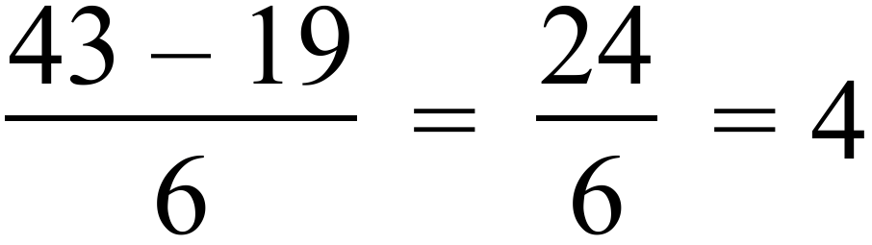
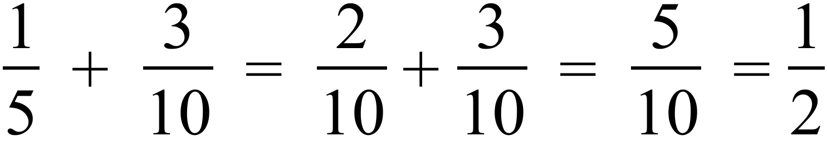
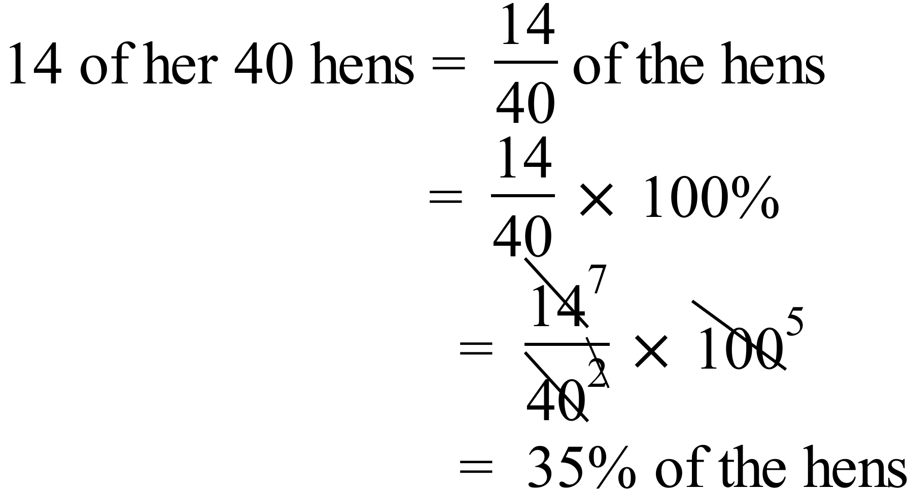
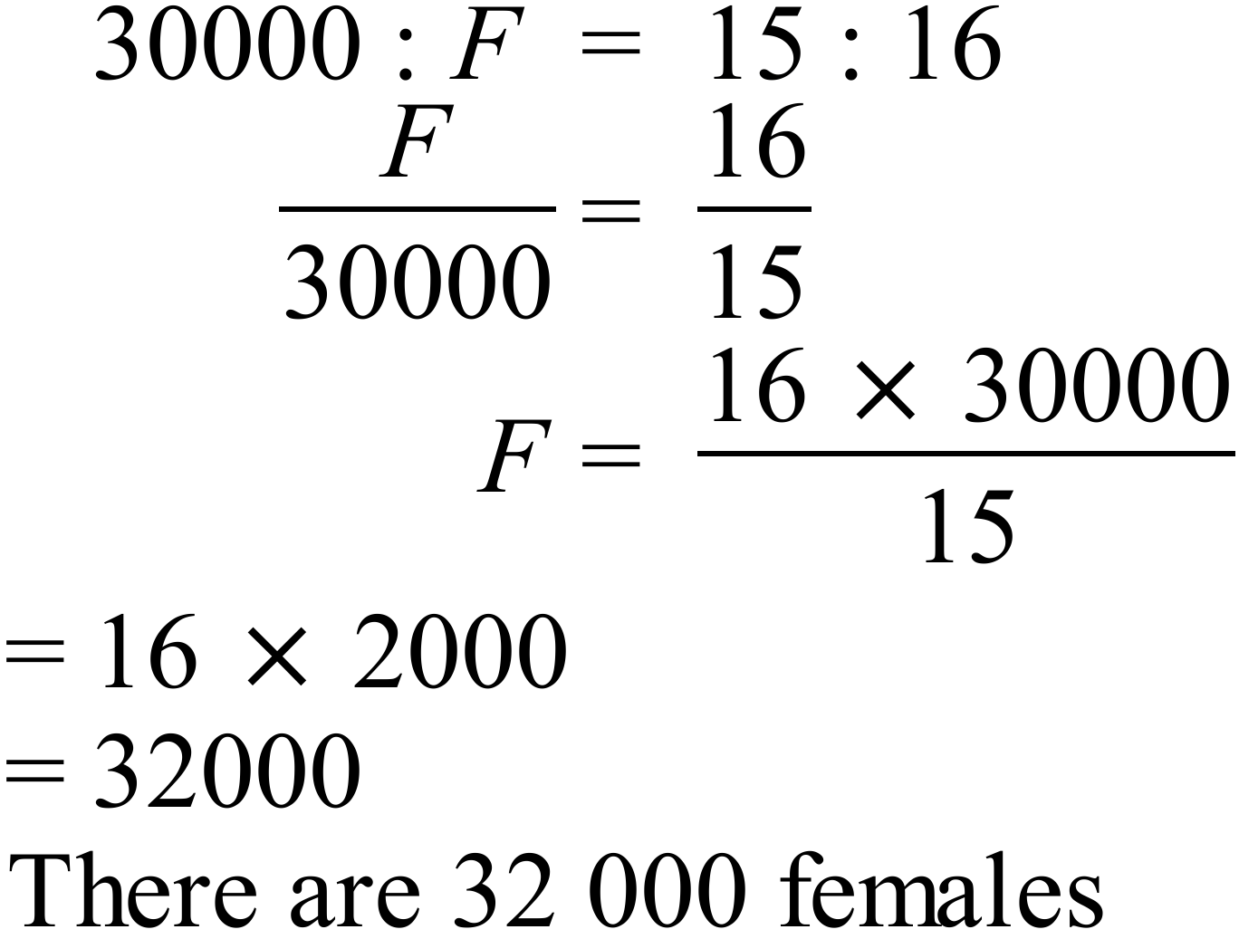
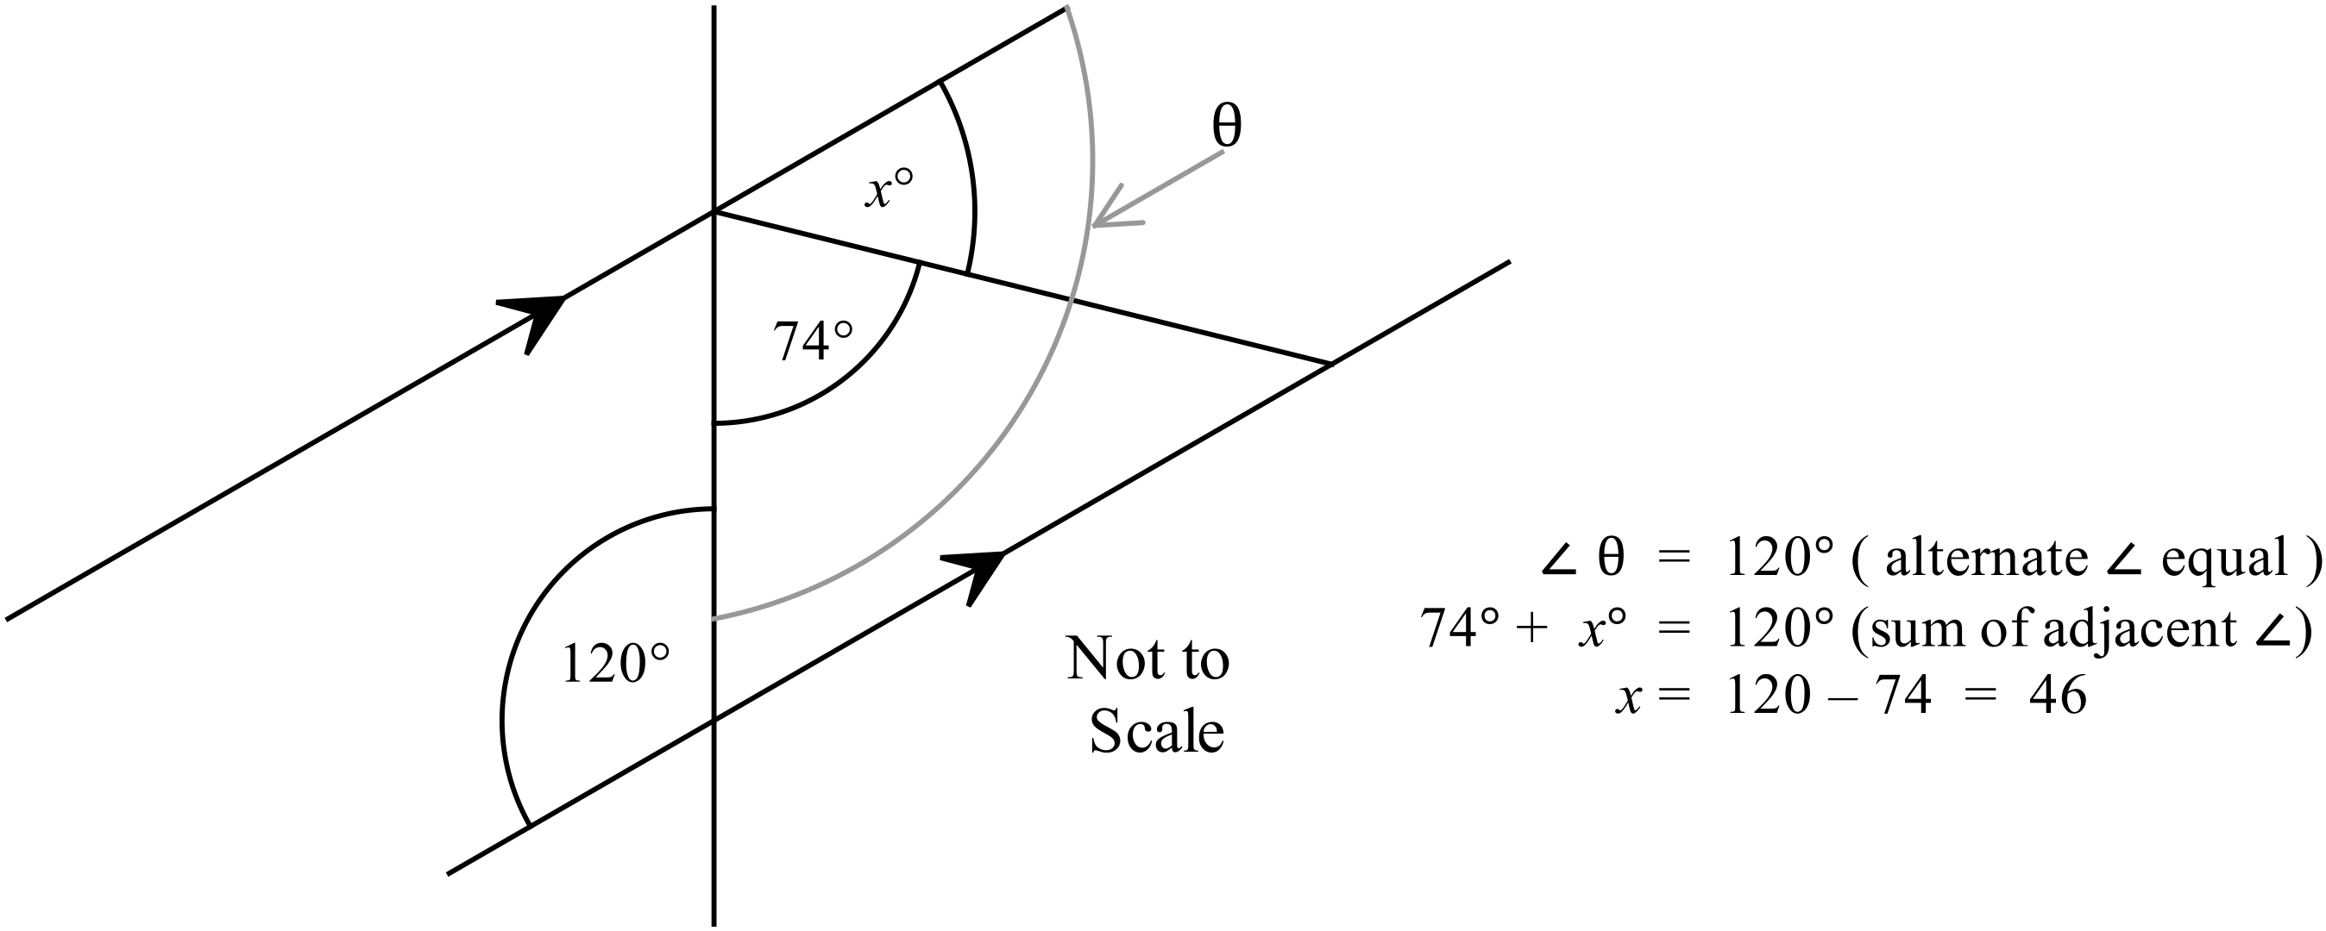

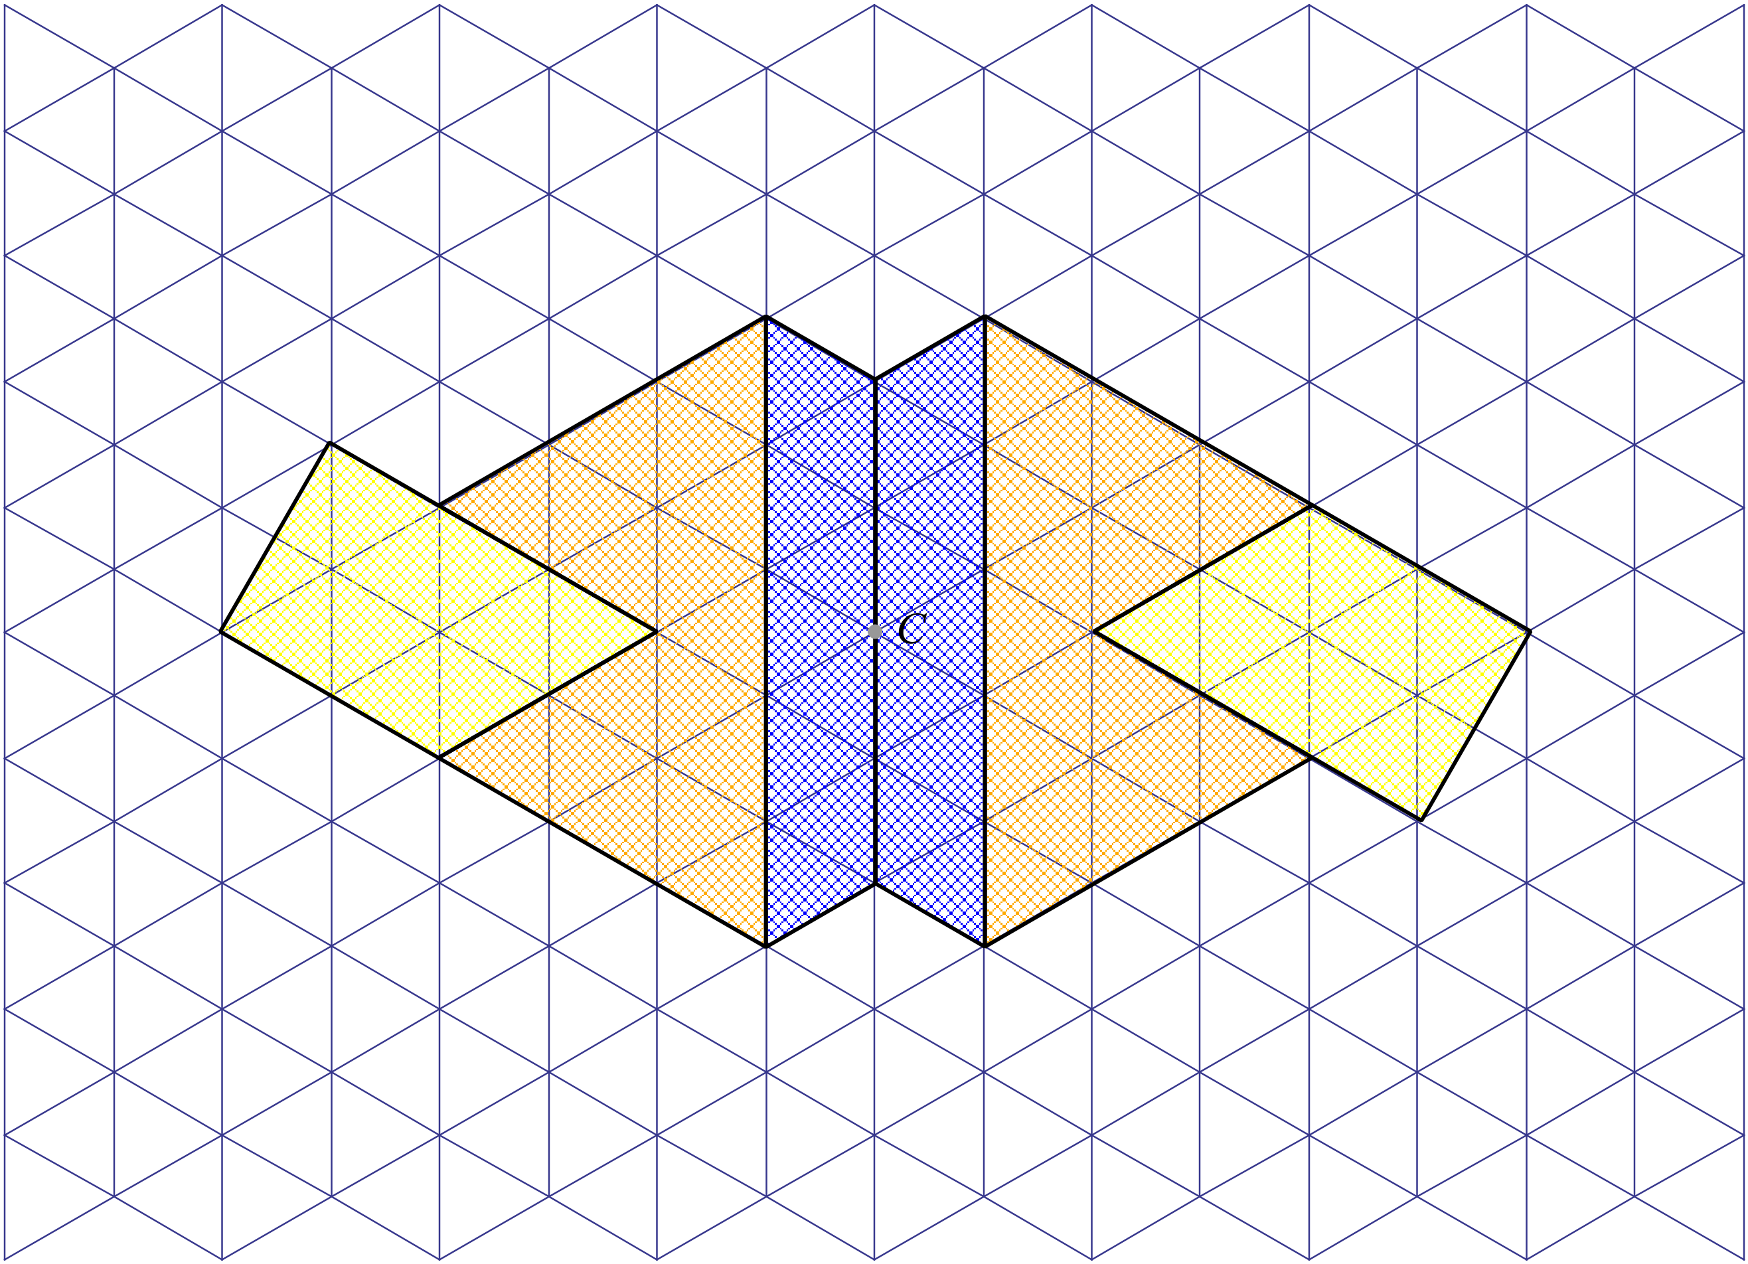

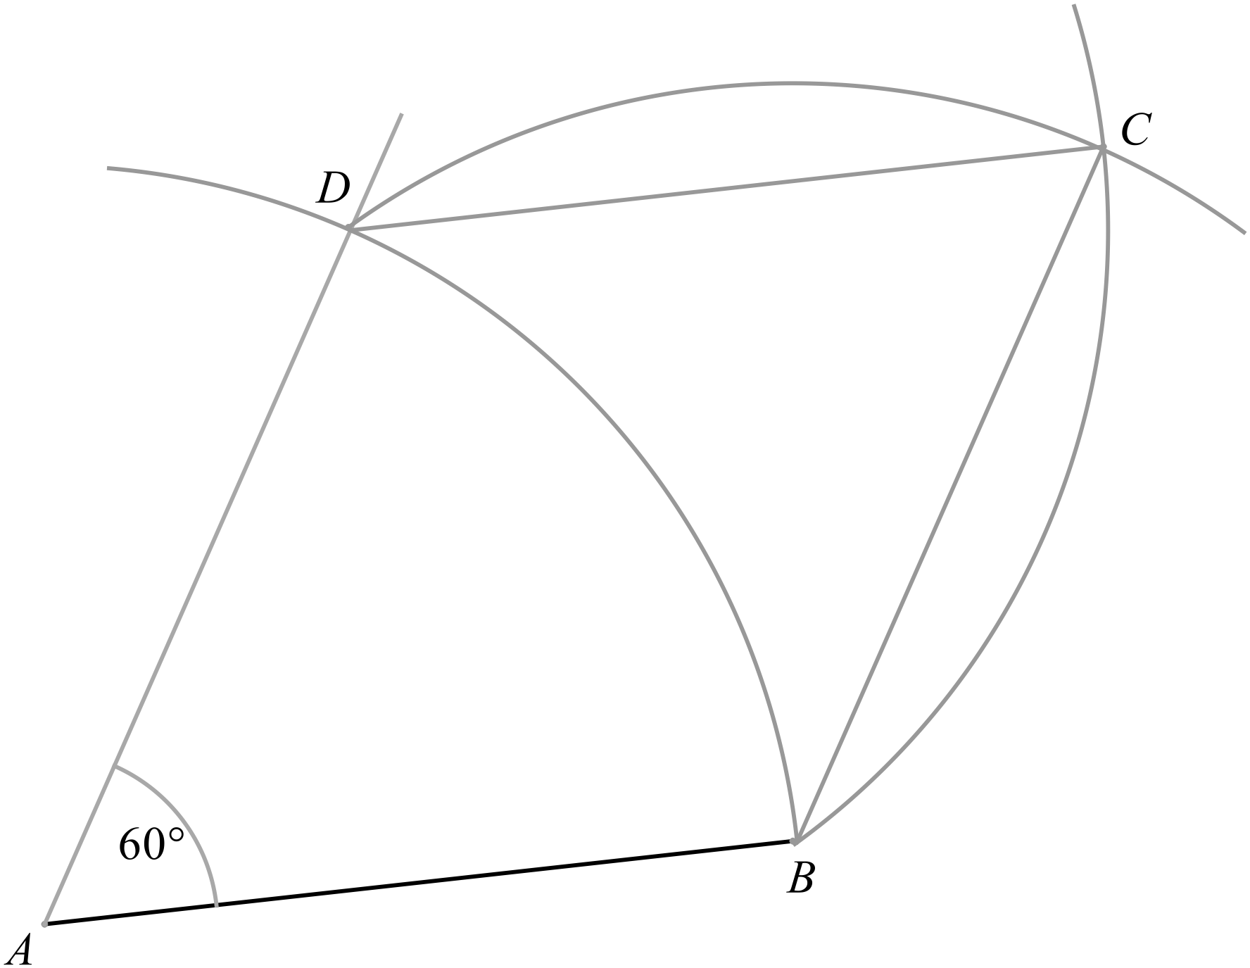

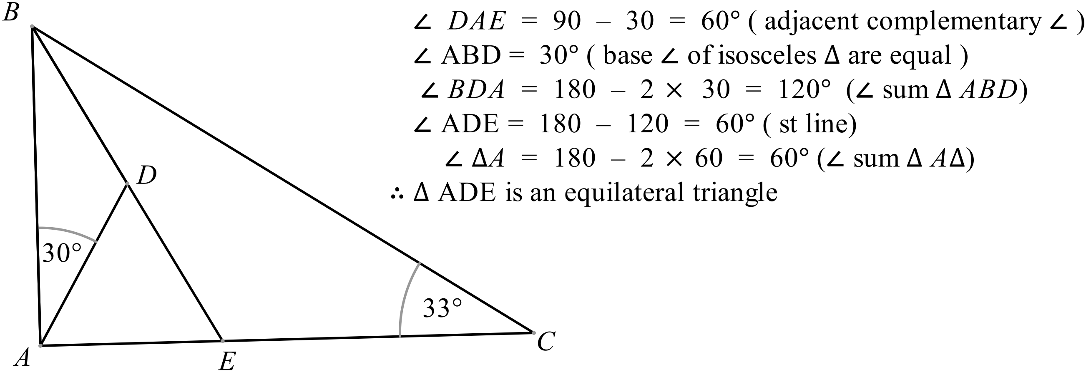

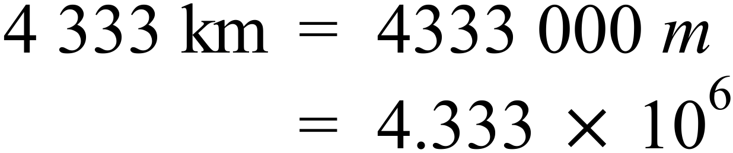
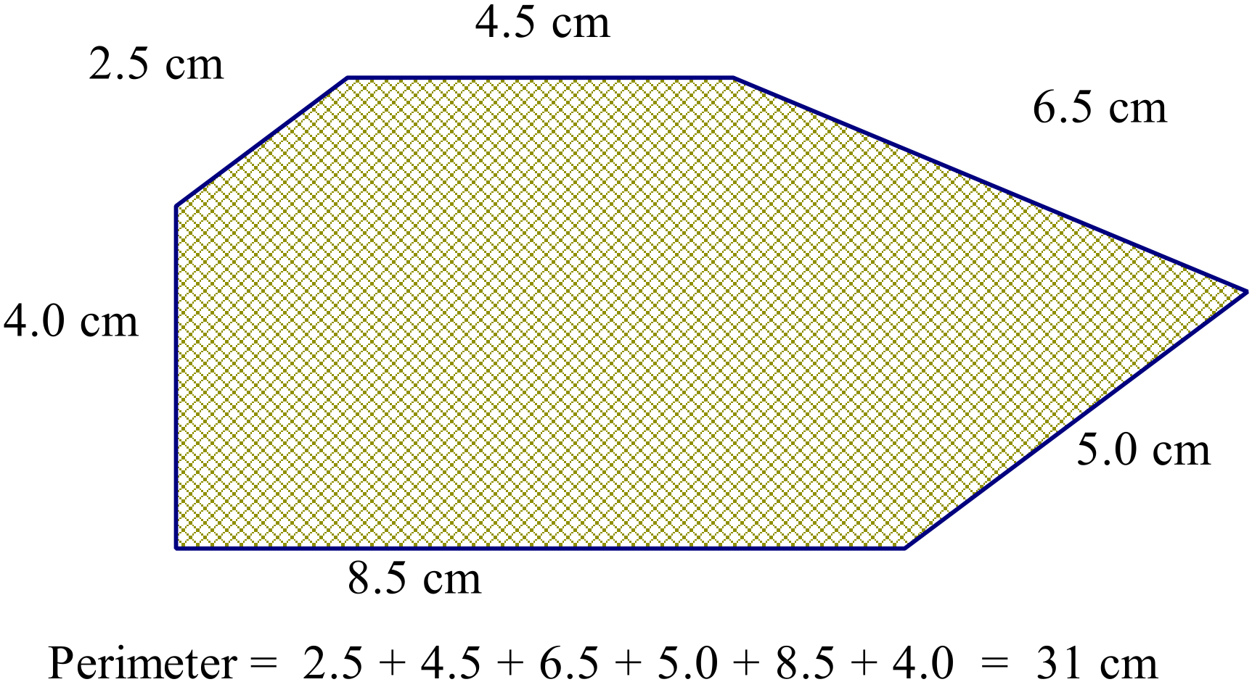

NB Different printers will produce small differences in the sizes of the diagram. Check your own printed copy by measuring, before marking student responses.

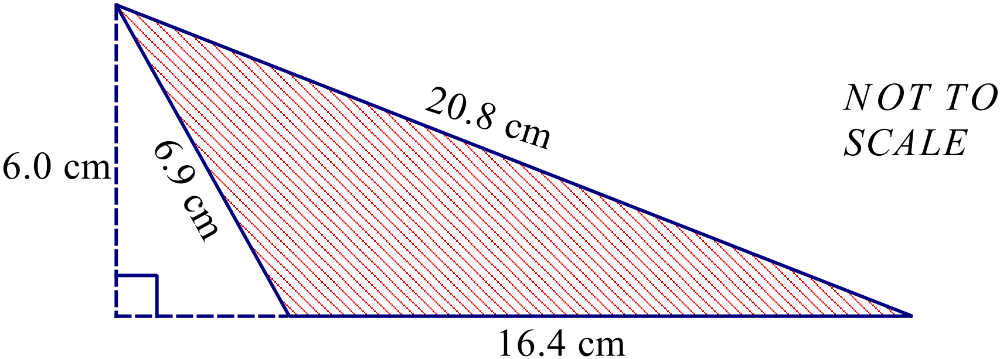

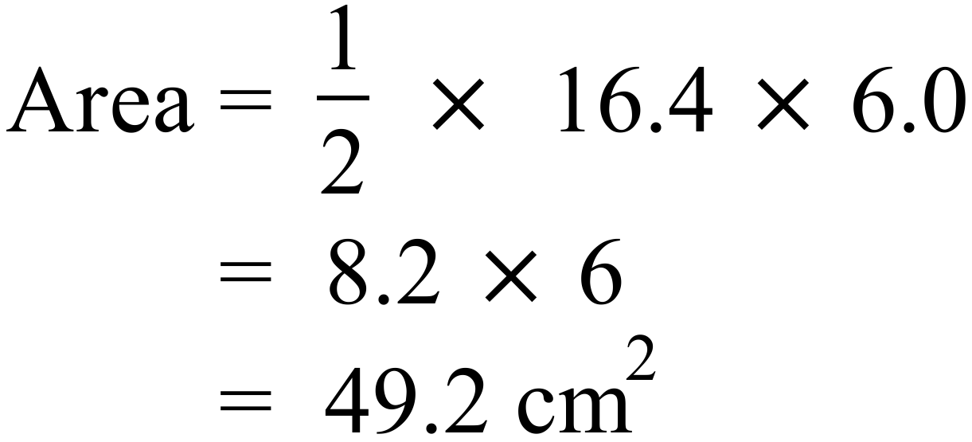

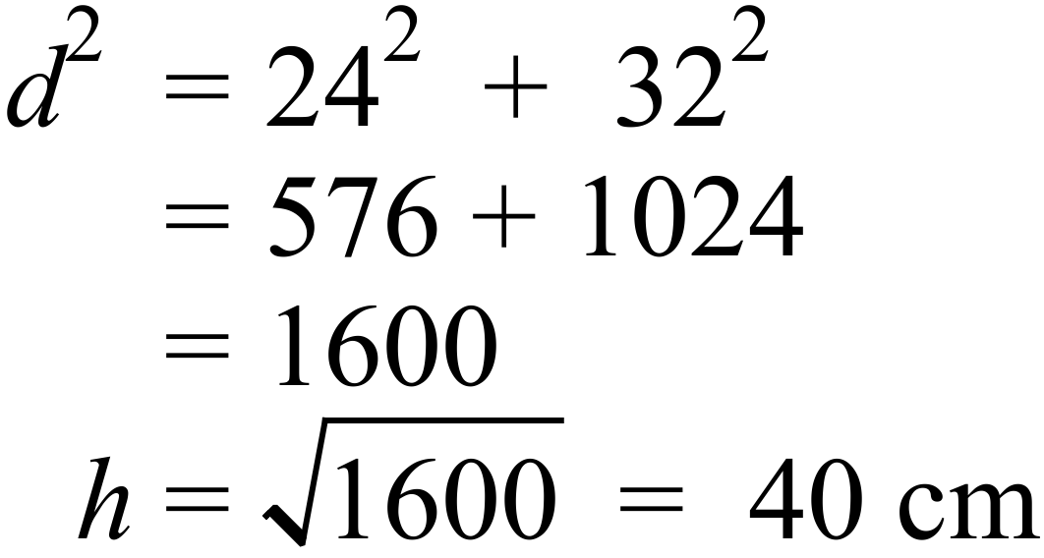
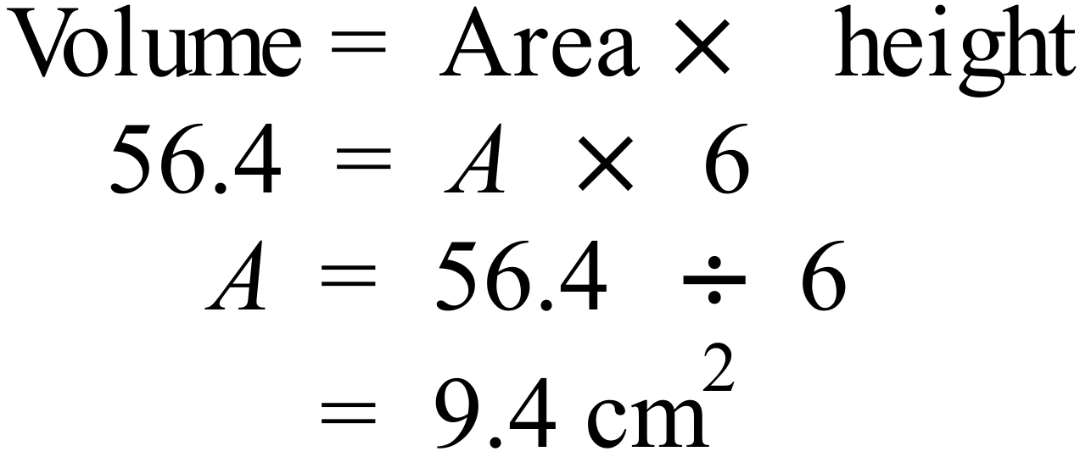
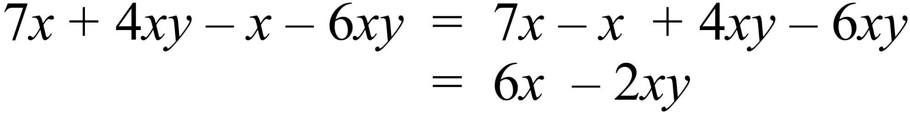
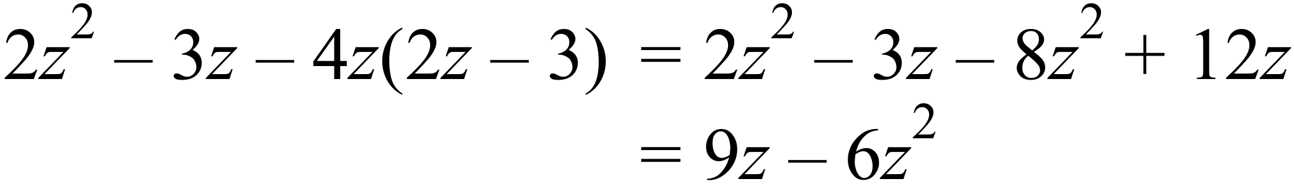
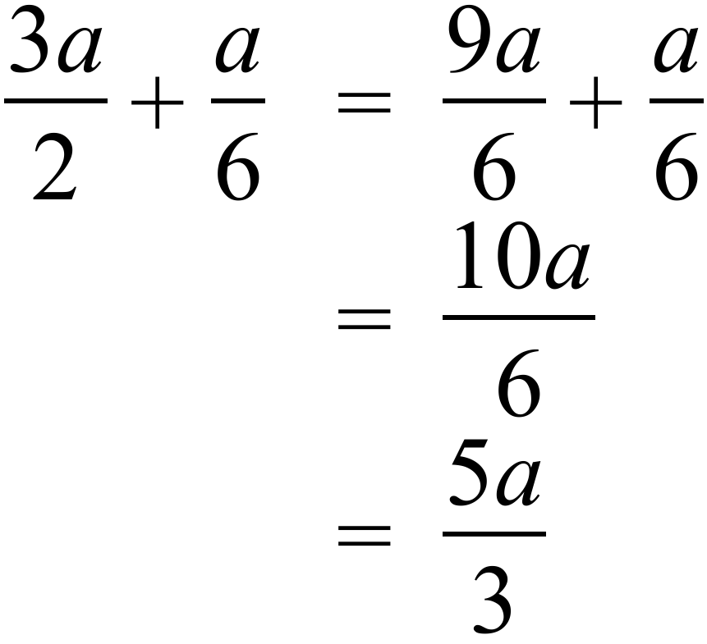
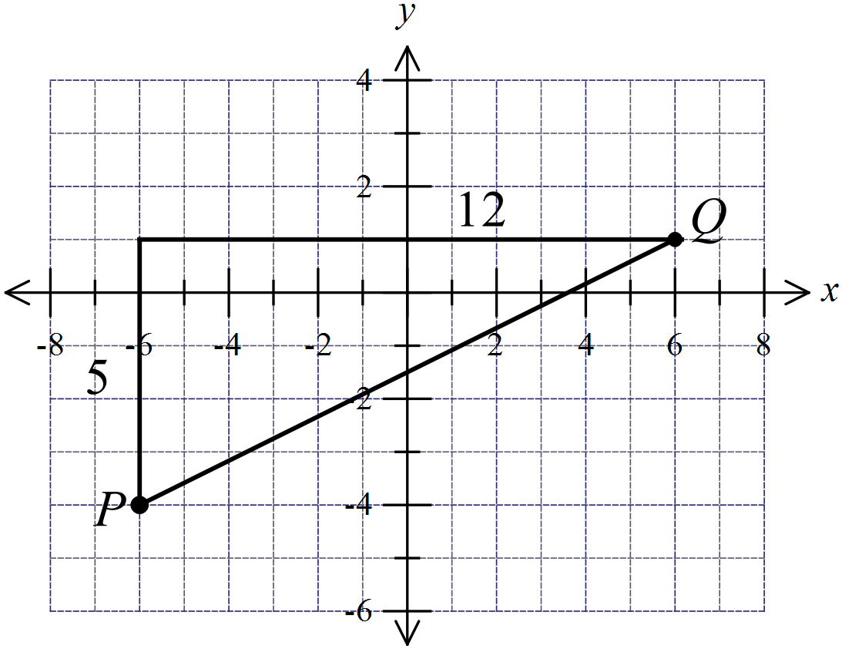

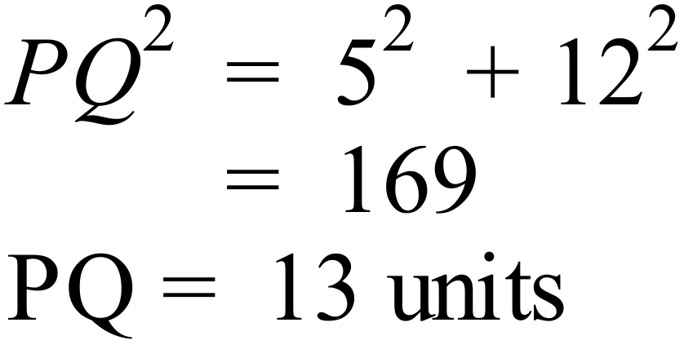

Or by using the distance formula

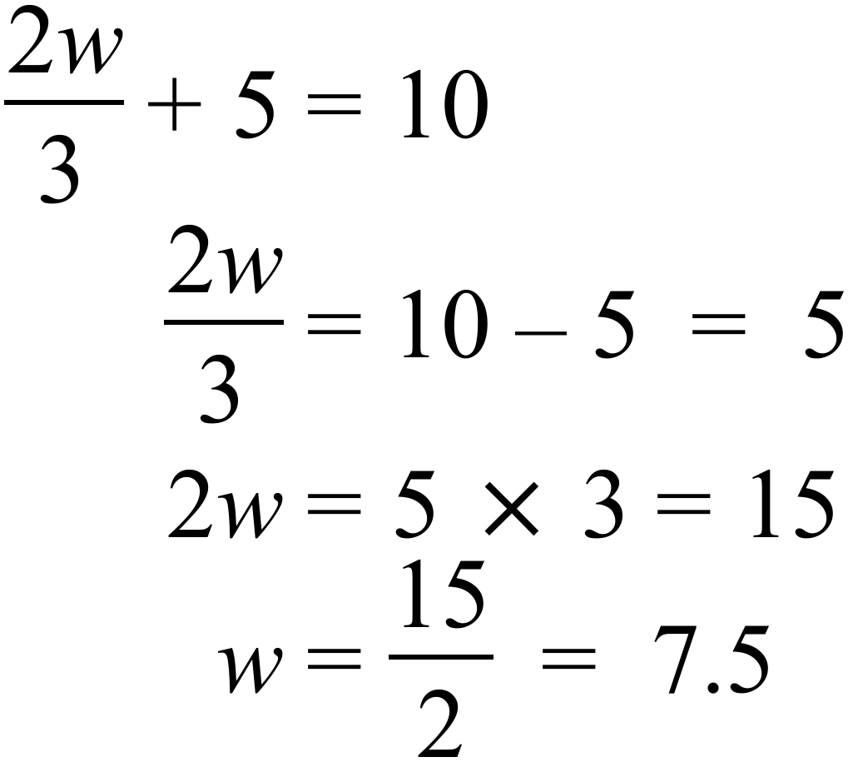
42 | 15 | 27 | 34 | 62
72 | 48 | 18 | 33 | 55
37 | 52 | 15 | 32 | 17
57 | 44 | 38 | 19 | 22

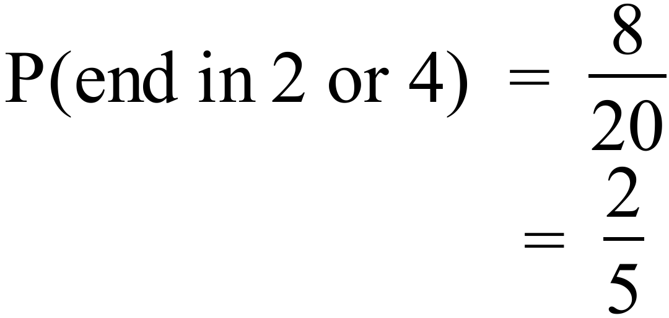
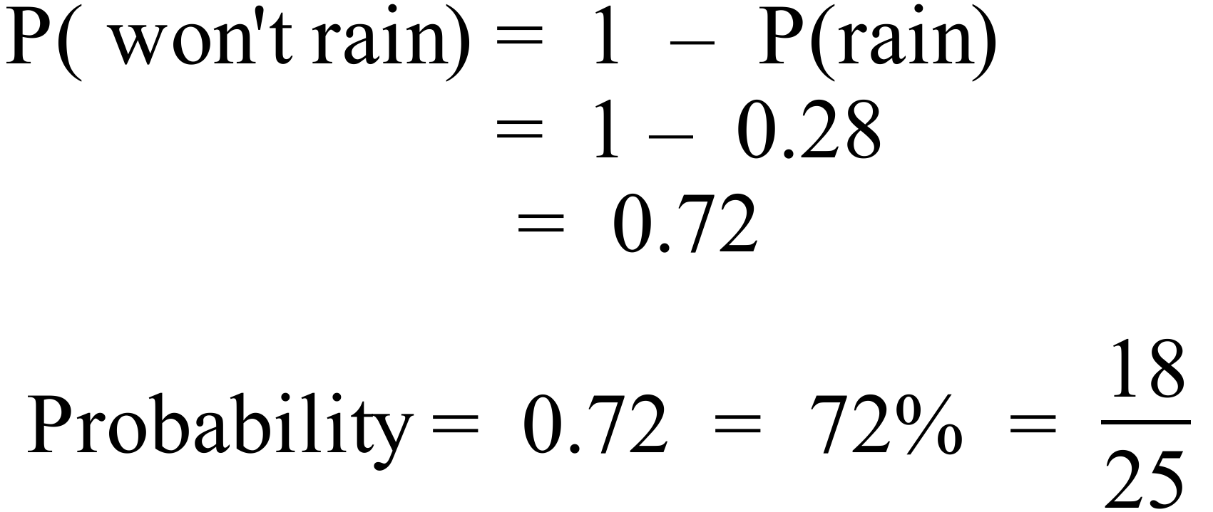
0 | 2
1 | 1 | 2
2 | 2 | X
3 | 0 | 2 | 3
4 | 2 | 3
5 | 0

Sum of scores given = 2+11+12+22+30+32+33+42+43+50 = 277
Missing score = 301 – 277 = 24
The X represents 4 to make 24.
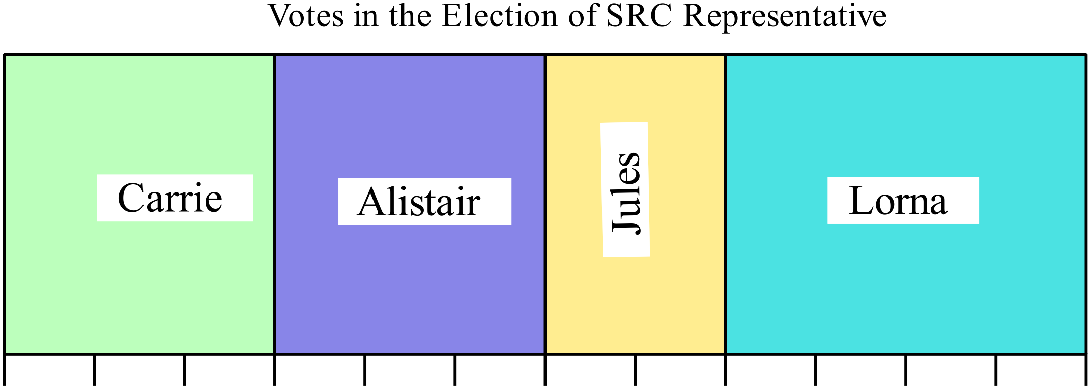

Length of whole graph = 12 units and length for winner (Lorna) = 4 units.
Votes for Lorna = 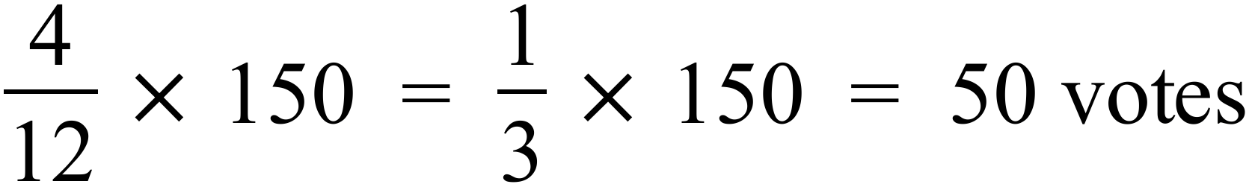
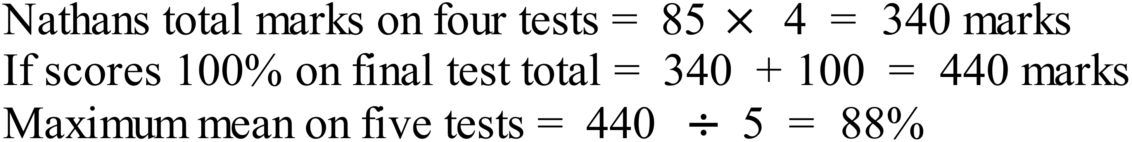
Arrange in order first.

11.0, 11.1, 11.2, 11.4, 11.4, 11.6, 11.9, 12.0, 12.1, 12.5

Lower Q Median = 11.5 Upper Q

Interquartile range = 12.0 – 11.2 = 0.8

2014 Yearly Mathematics Exam
Multiple Choice Section
Answers
 | 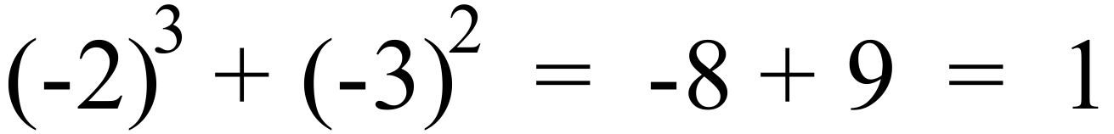 | D
 | 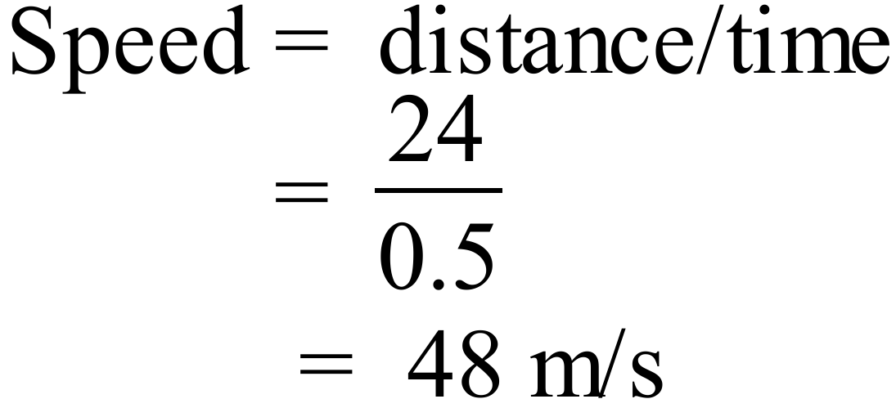 | C
 | 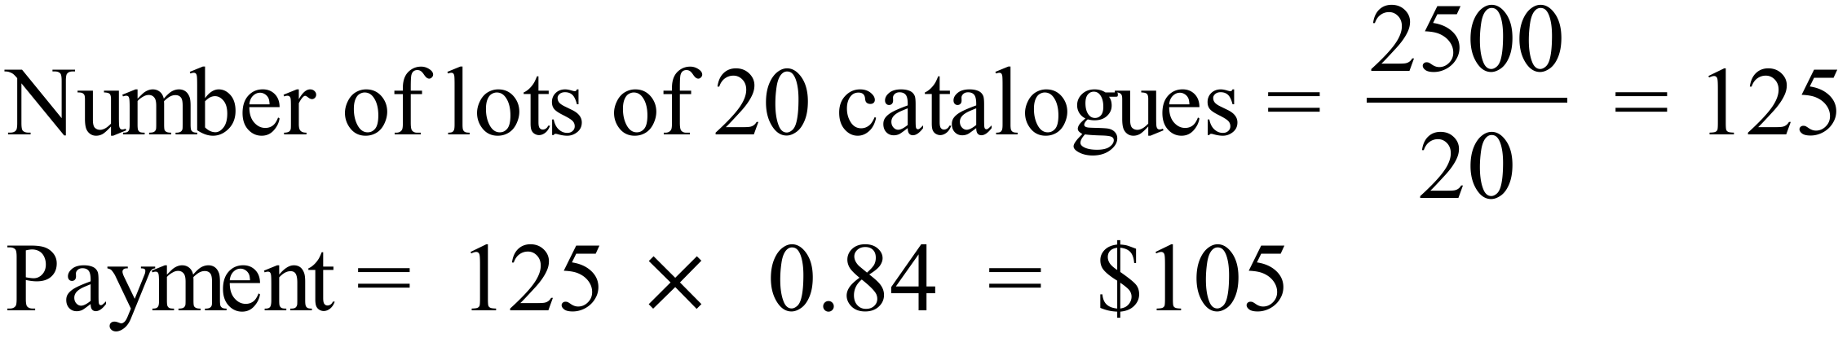 | A
 | 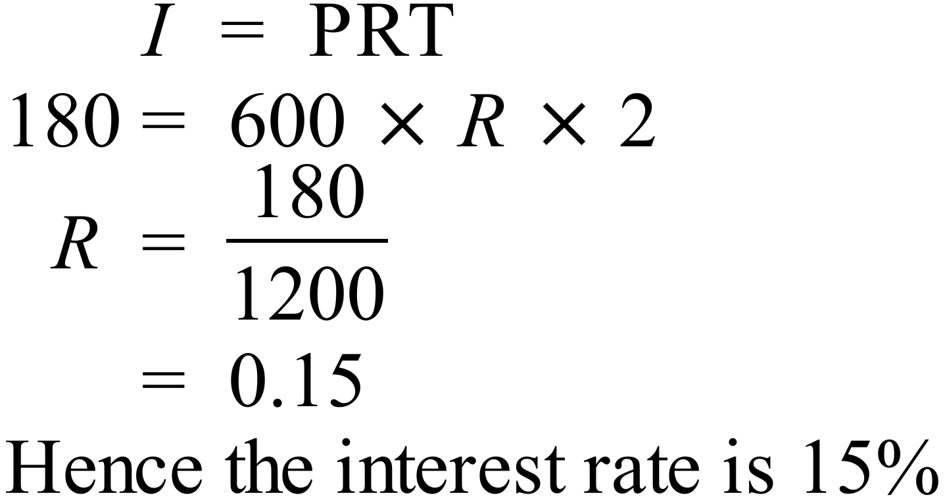 | C
 | 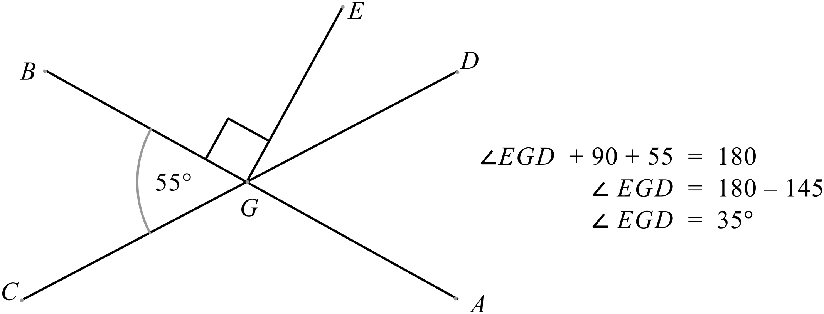 | A
 | 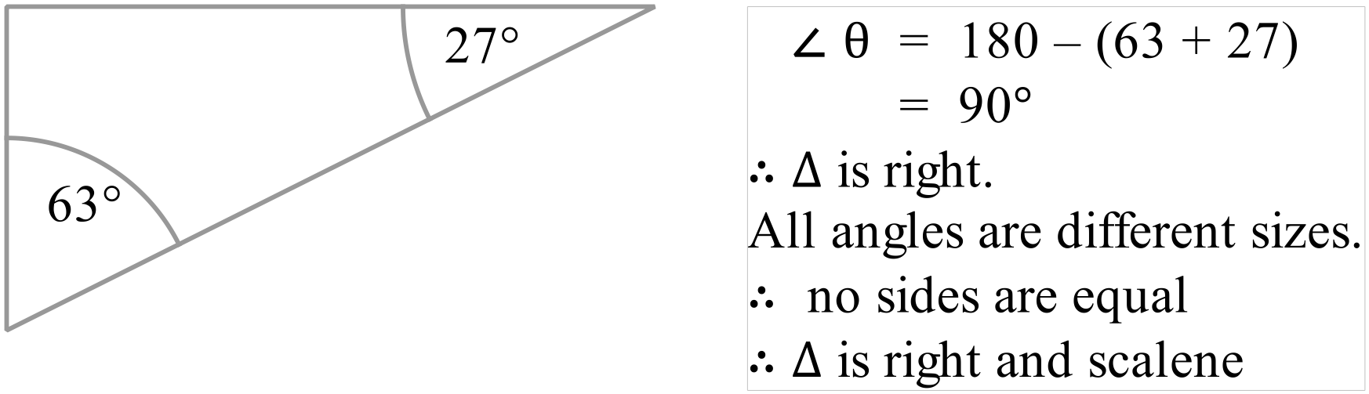 | B
 | 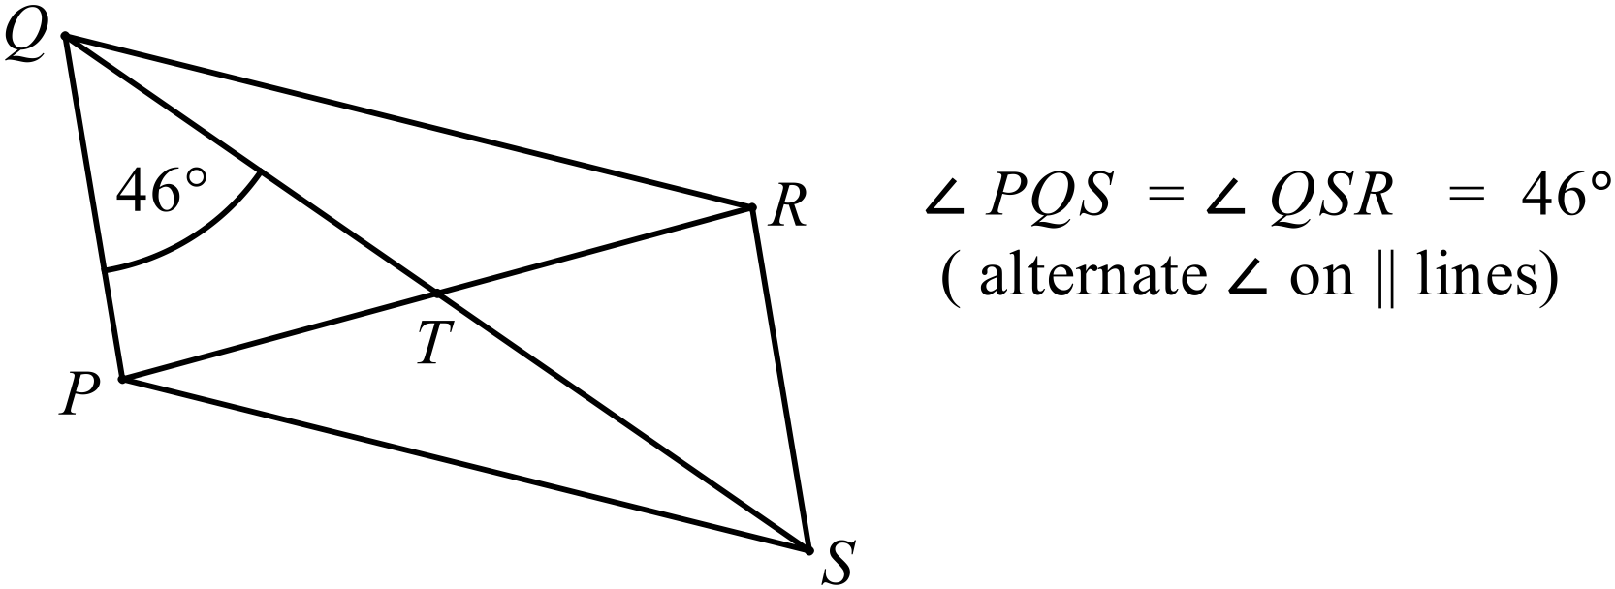 | D
 | 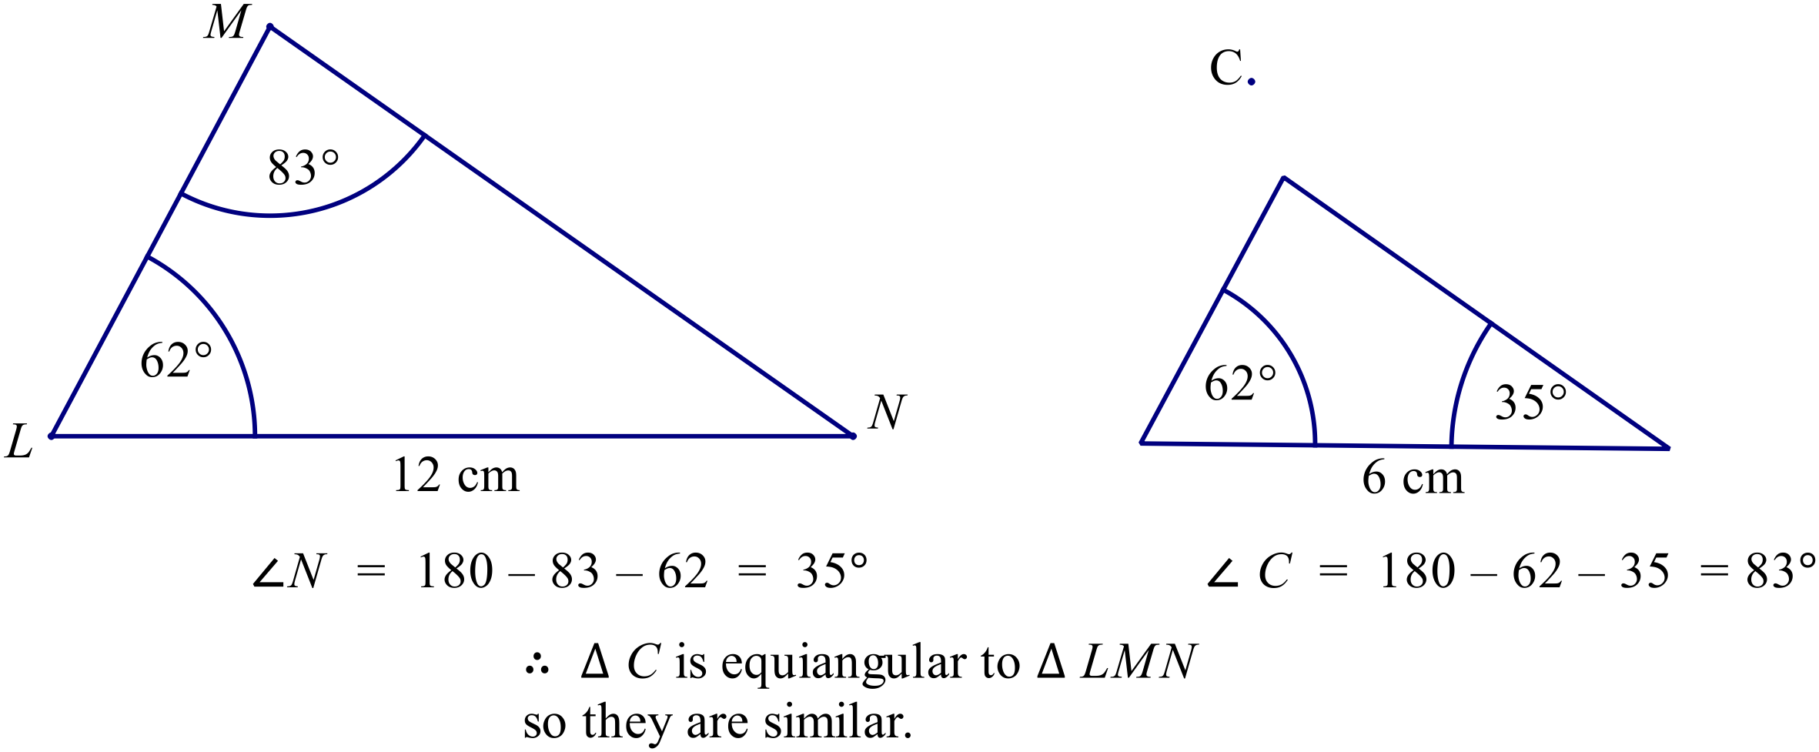 | C
 | 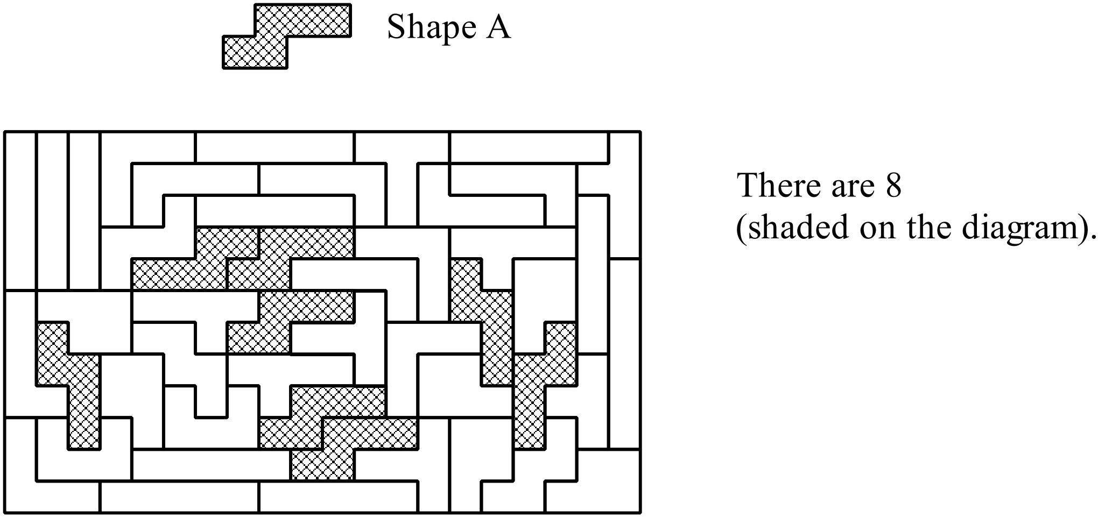 | C
 | 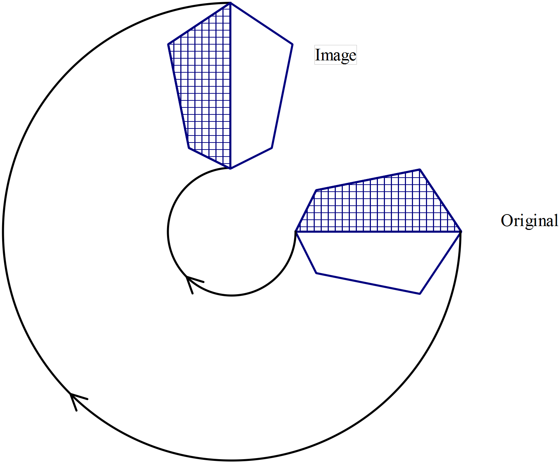 | D
 | 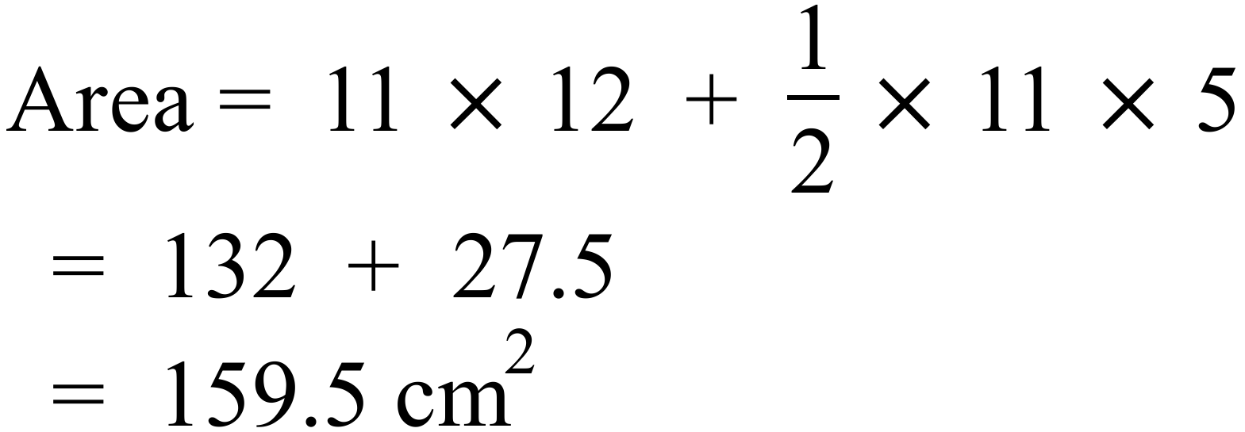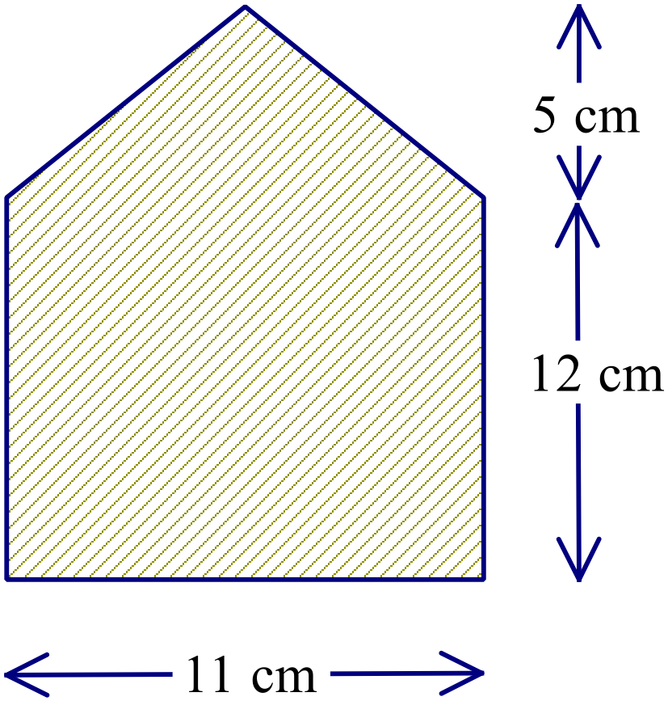 | C
 | 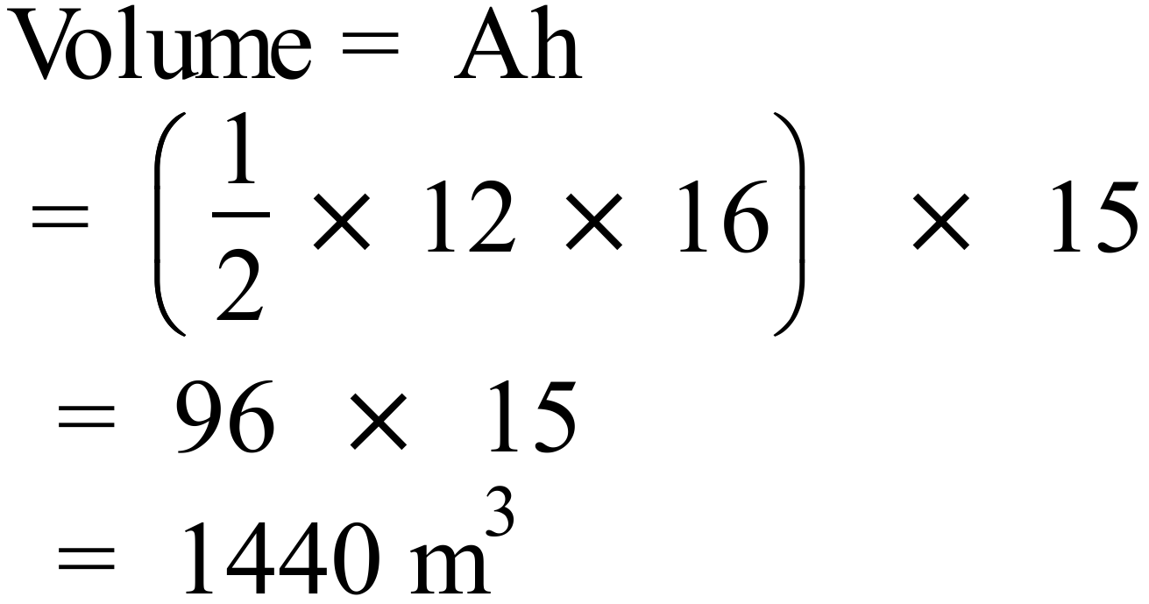 | B
 | 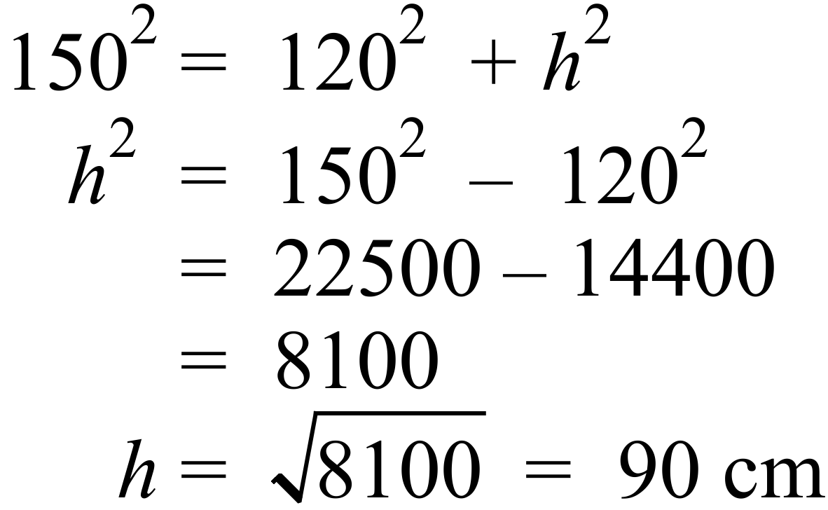 | B
 | 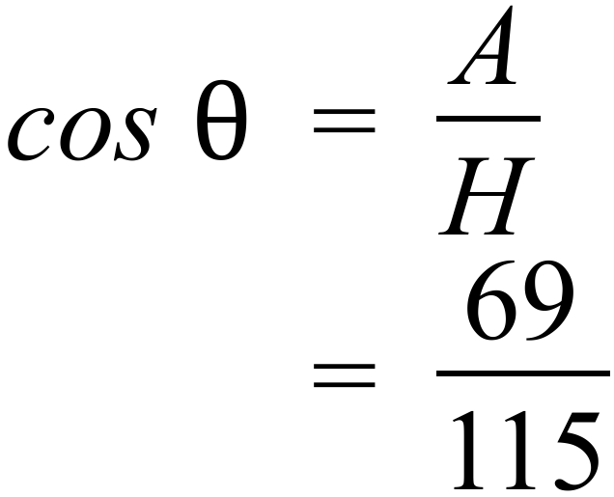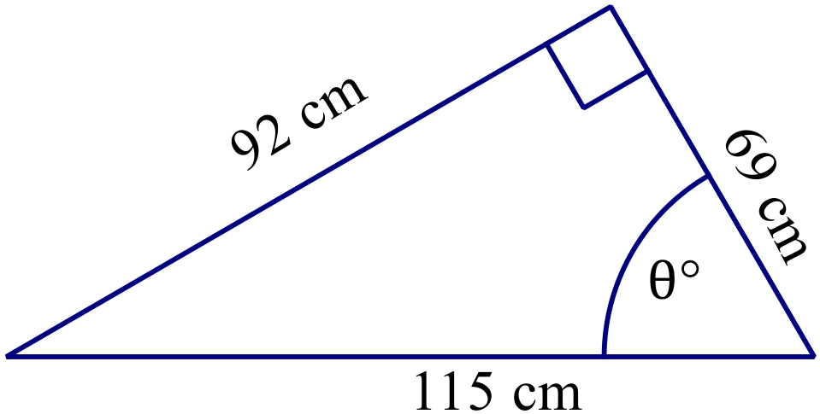 | A
 | 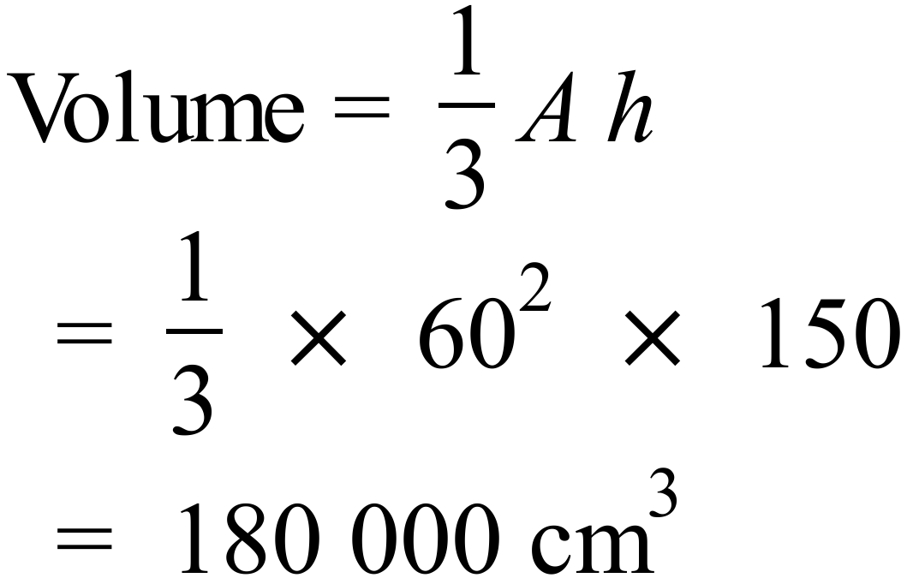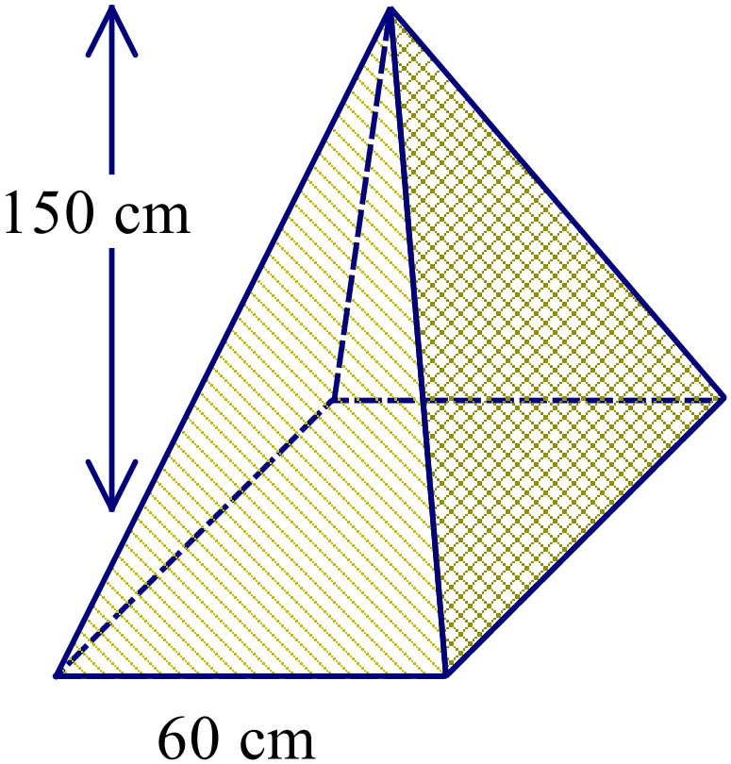 | D
 | 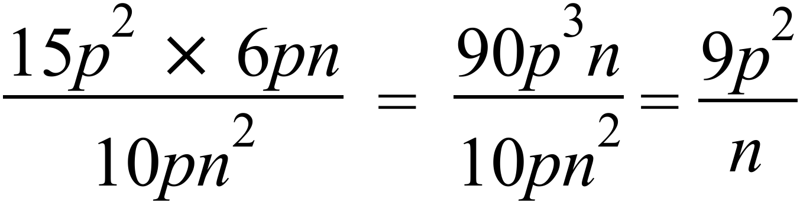 | B
 | Midpoint of U(-3, 8) and W(-7, -6).  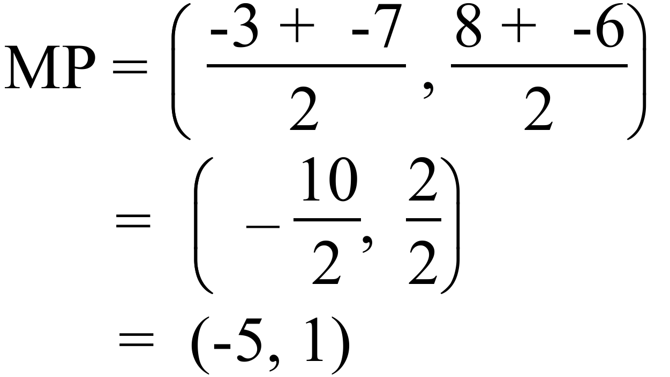 | A
 | 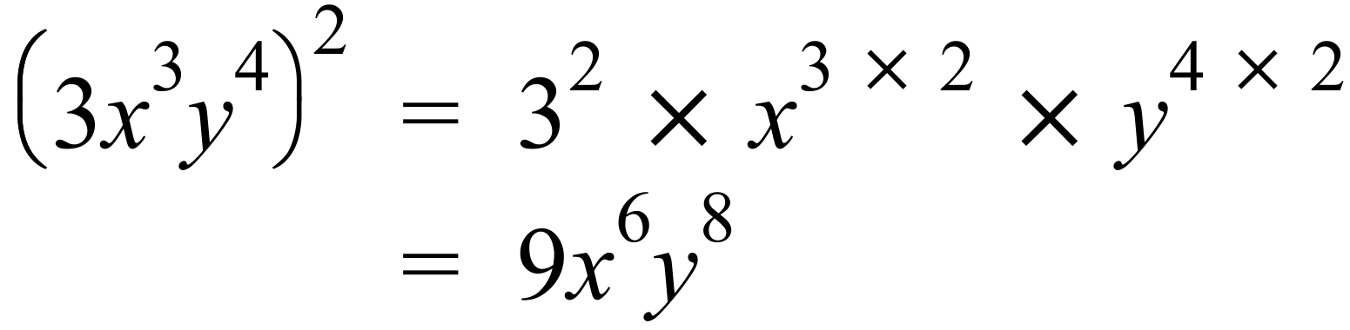 | D
 | 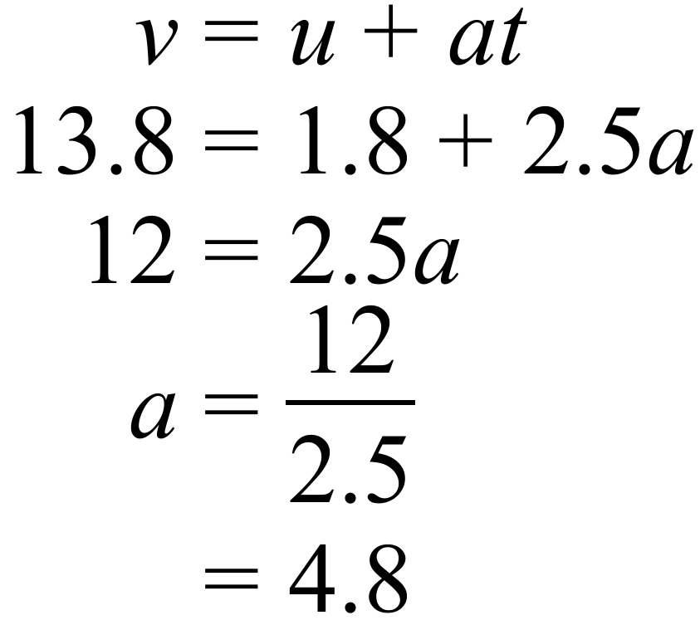 | D
 | 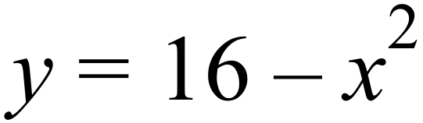 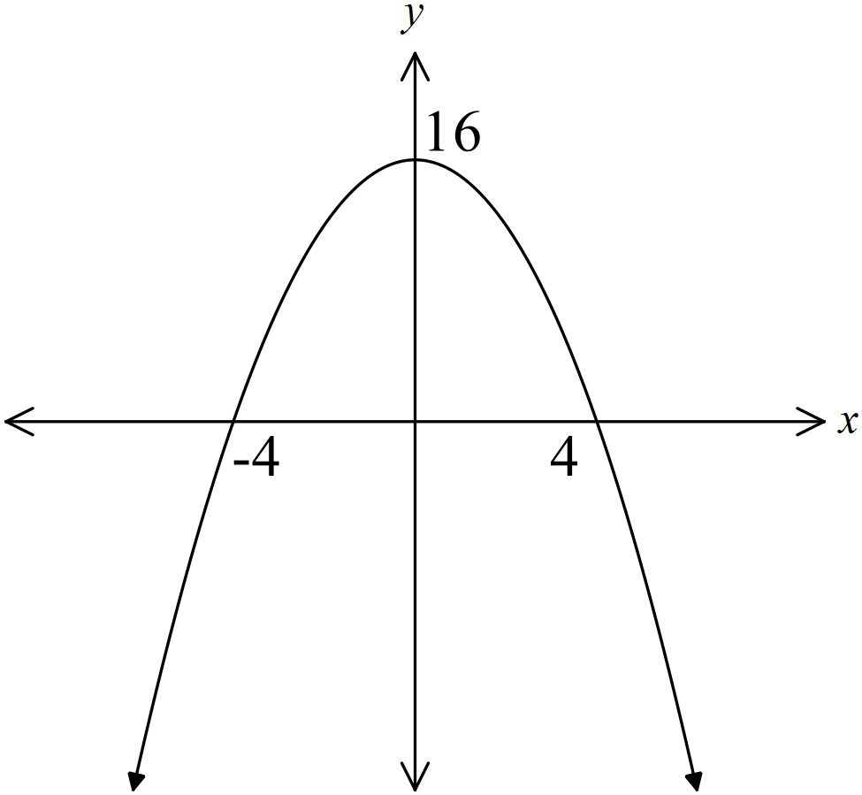is a concave  down parabola passing  through 16 on the y axis. | A
 | Very likely indicates a high probability, reasonably close to 1, so 0.8 is the best to suit this situation. | D
 | He asked 250 people out of the 2 000 people so it is a sample.  The answer to the question will be names, so it is categorical data. | B
 | - 56% of Anderson’s employees are male.  Less than half are male, so this is false.  - 43% of Beattie’s’s employees are male.  More than half are male so this is false.  - Curran has half the number of female employees as Evans.  Curran has 10 and Evans has 20 so this is true.  - Dowler and Beattie have the same number of male employees  Beattie has more than Dowler, so this is false. | C
 | 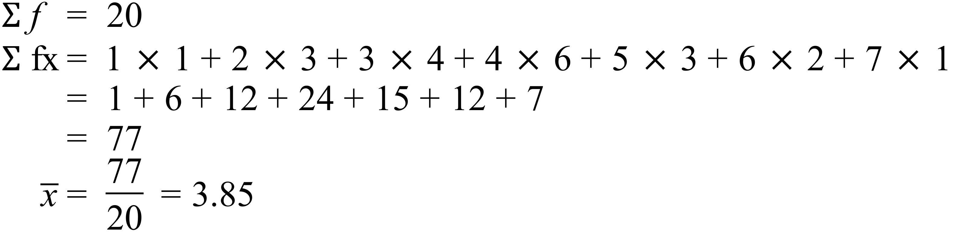 | B
 | There is a 7 degree increase between 8 am and 9 am which is the greatest. | A
 | 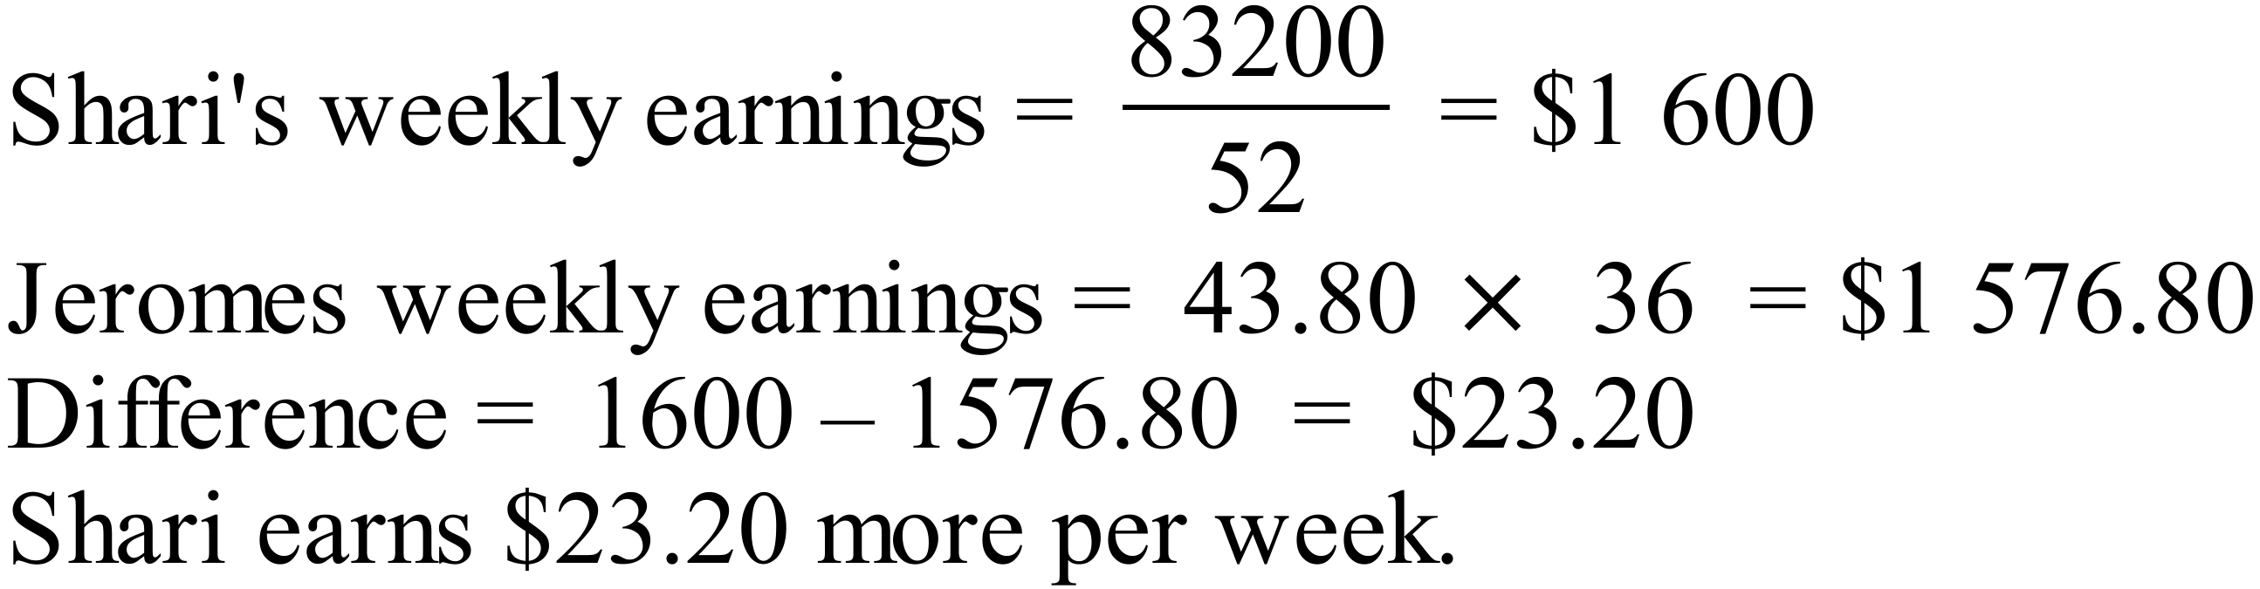 | C
 | 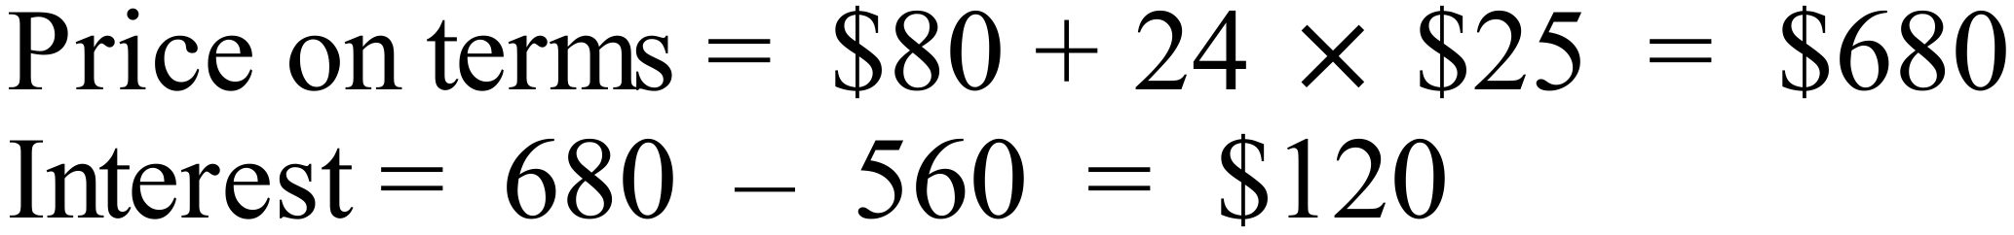 | B
 | 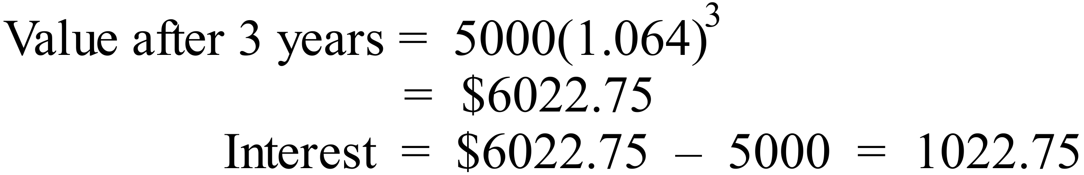 | B
 | Value has halved when it reaches $20 000.  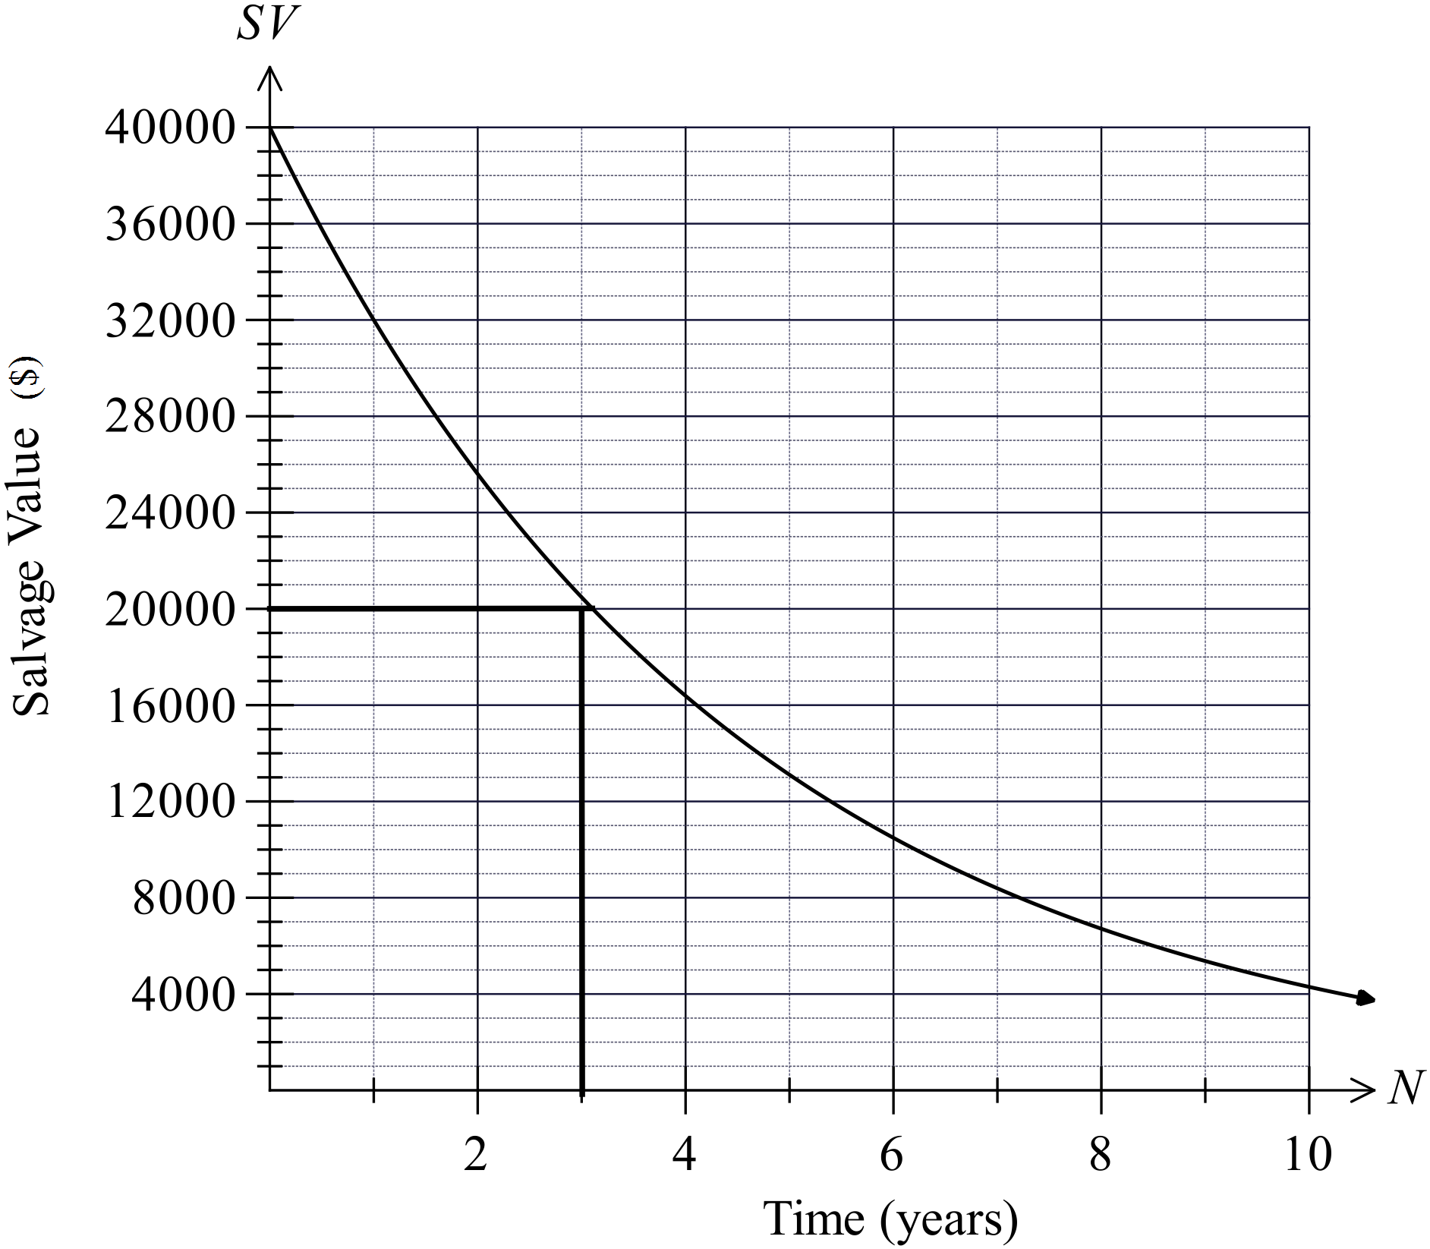  From Graph this is after 3 years. | D
 | 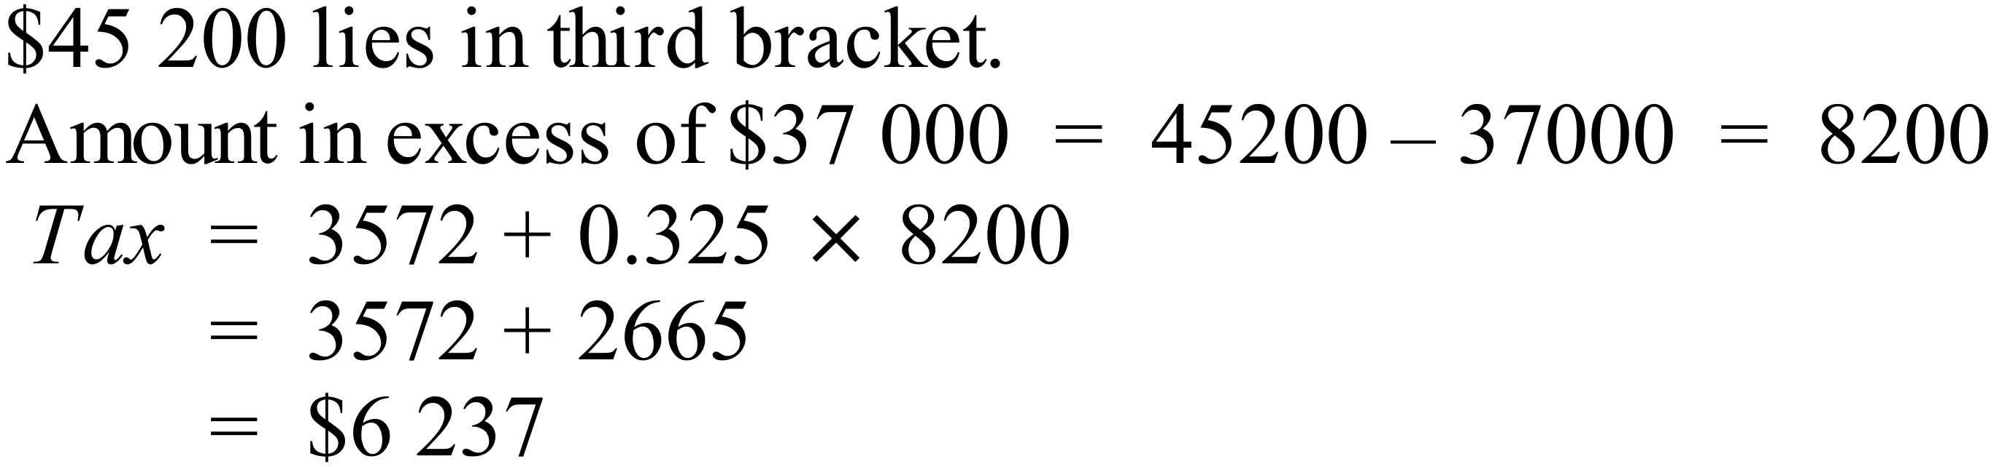 | D
 | 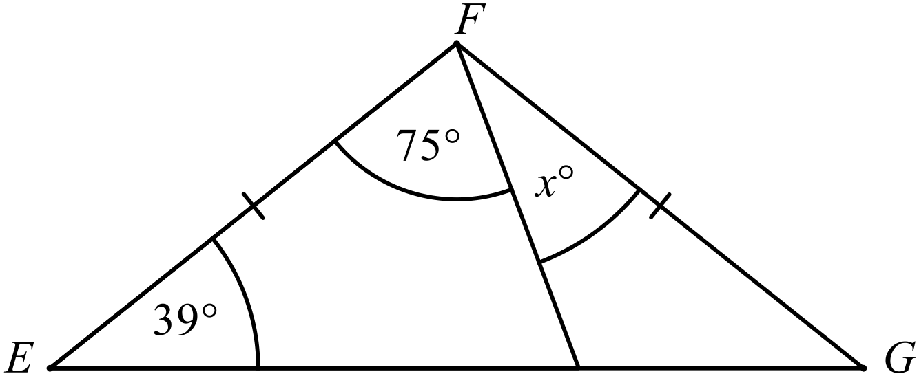  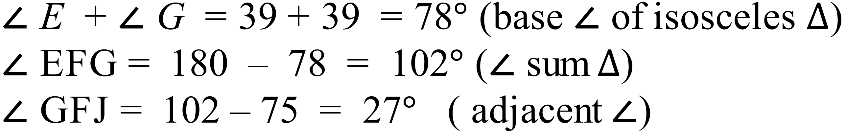 | A
 | 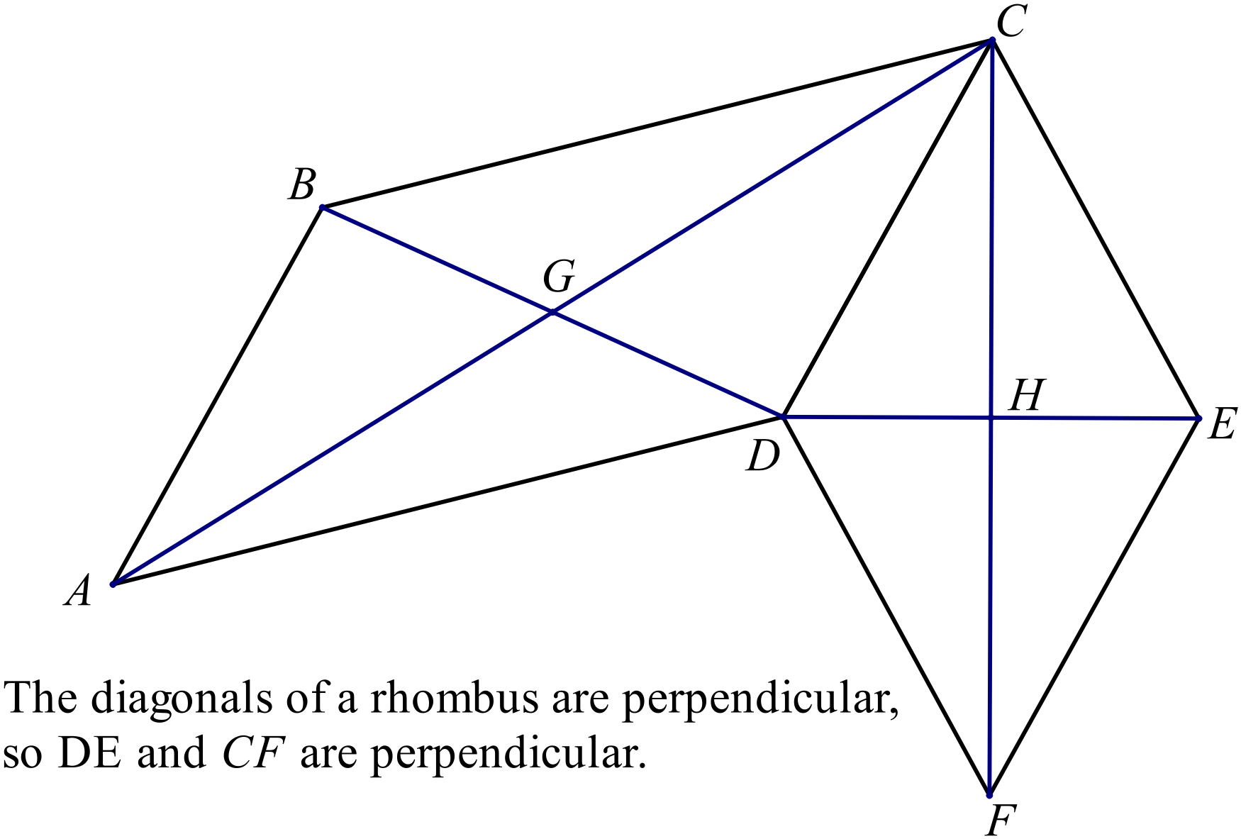 | D
 | 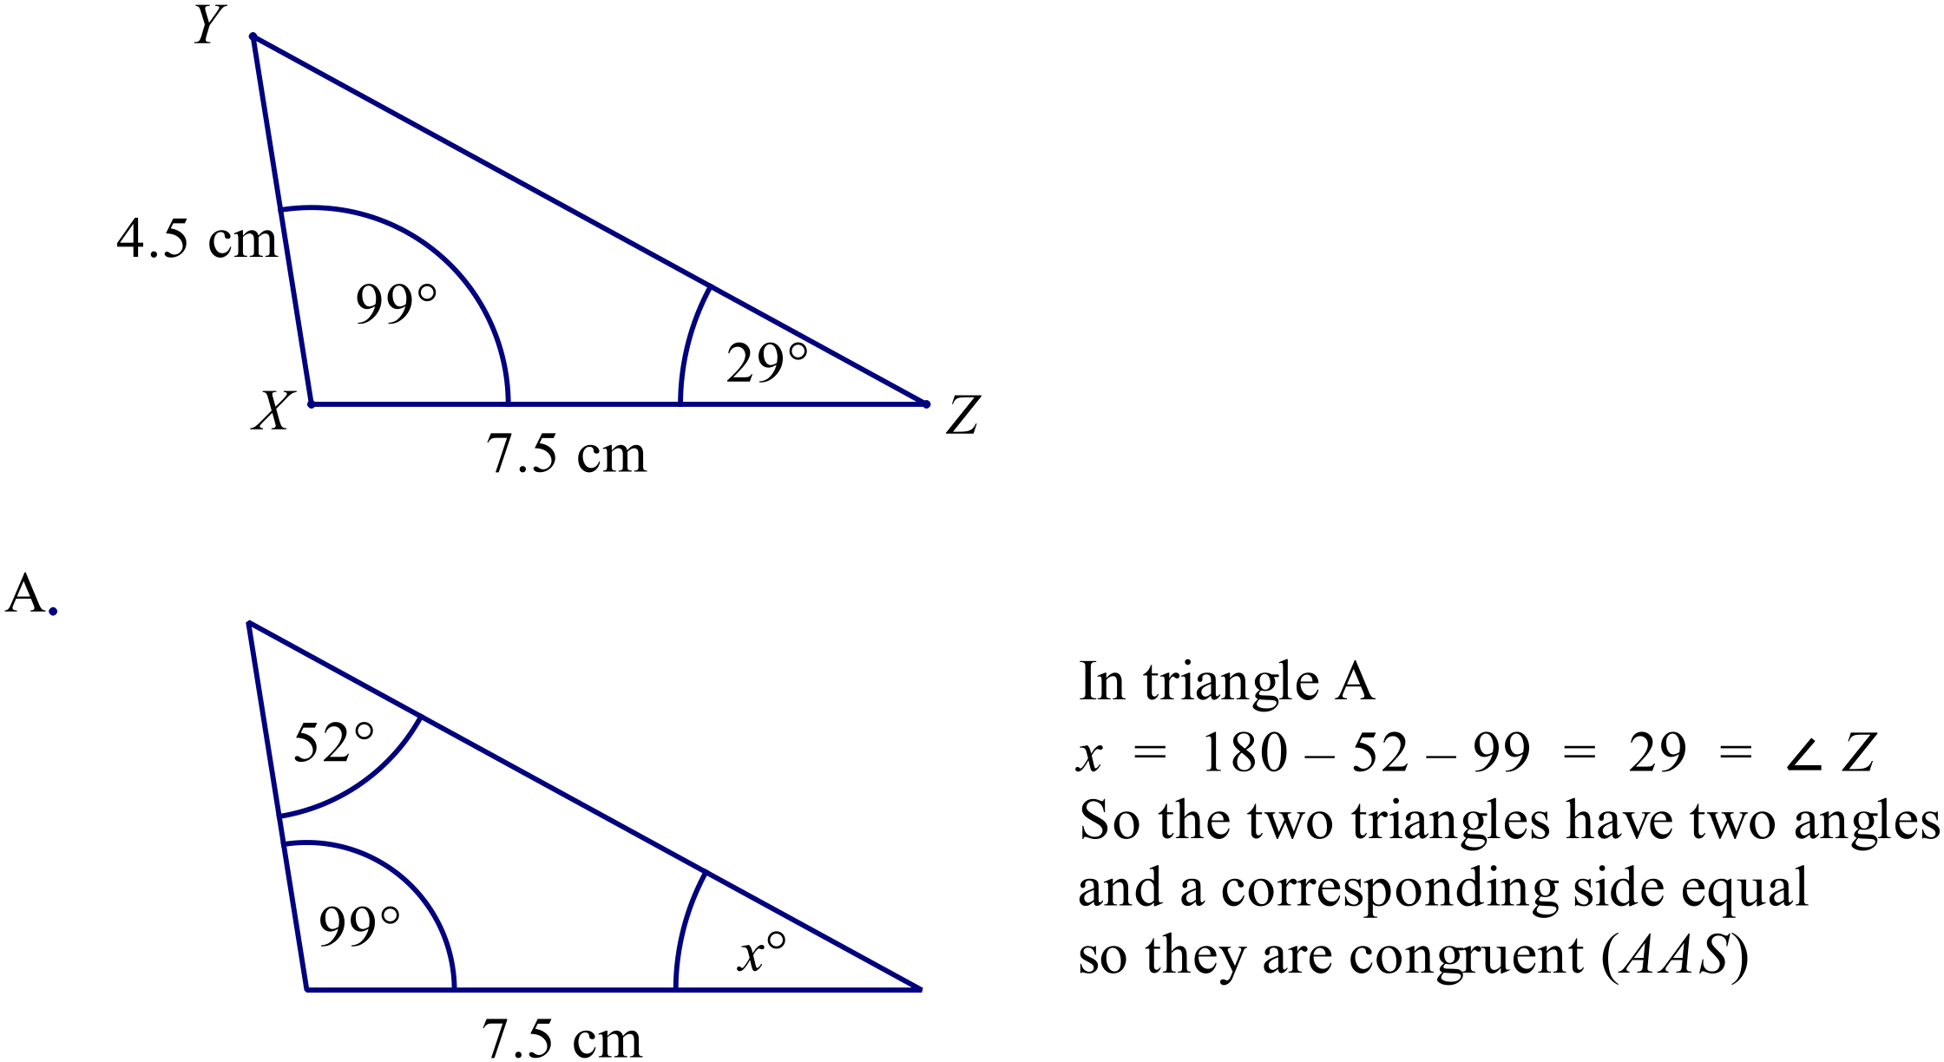 | A
 | 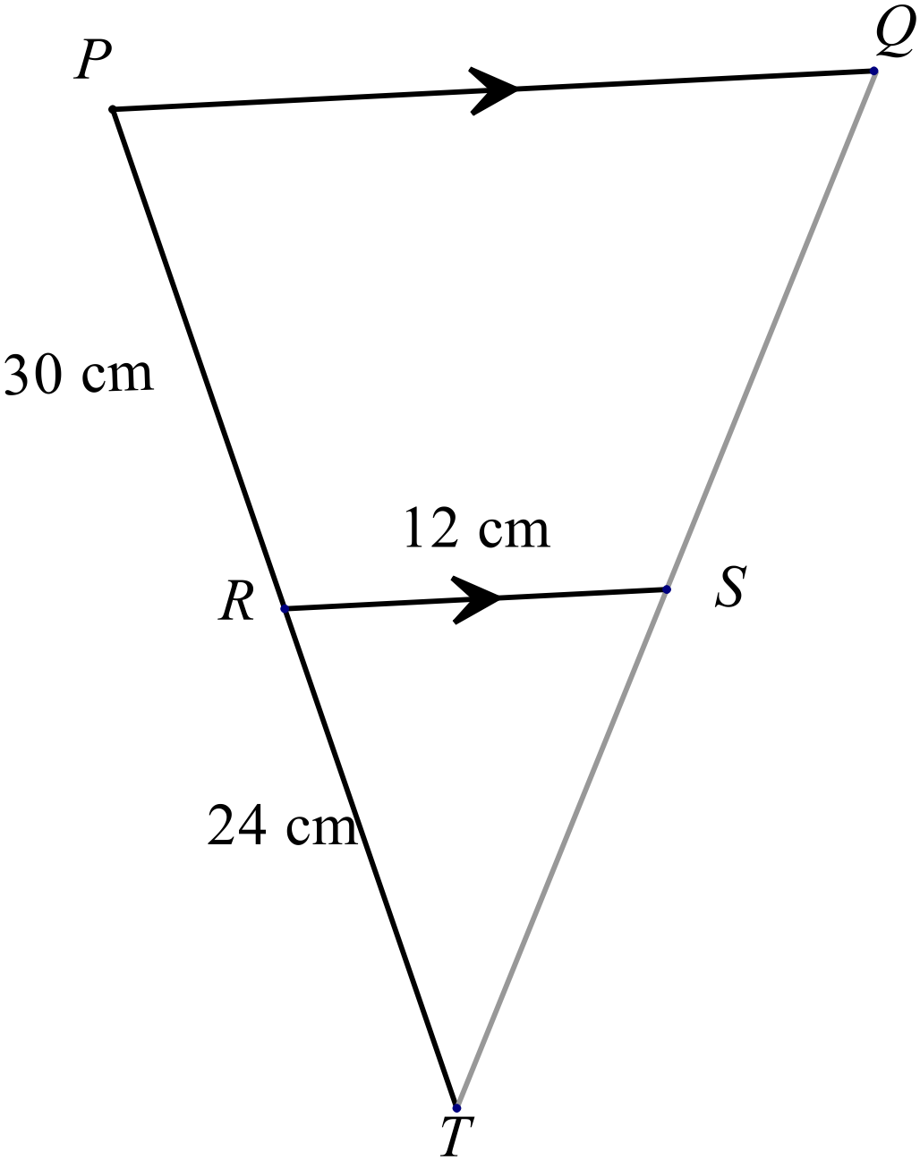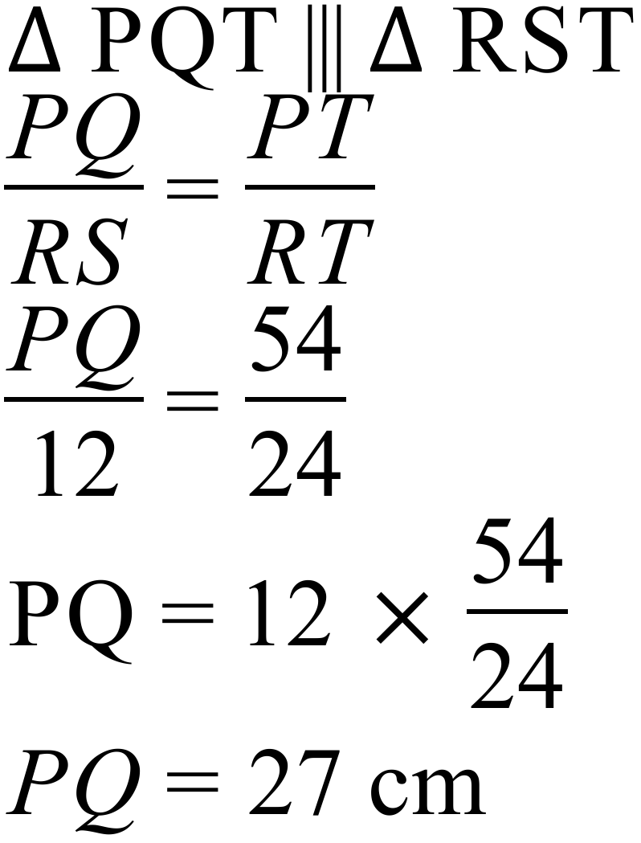 | C
 | 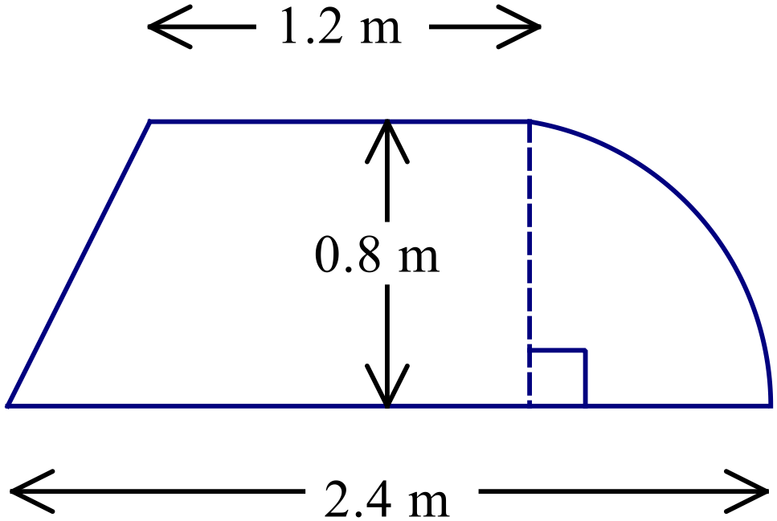  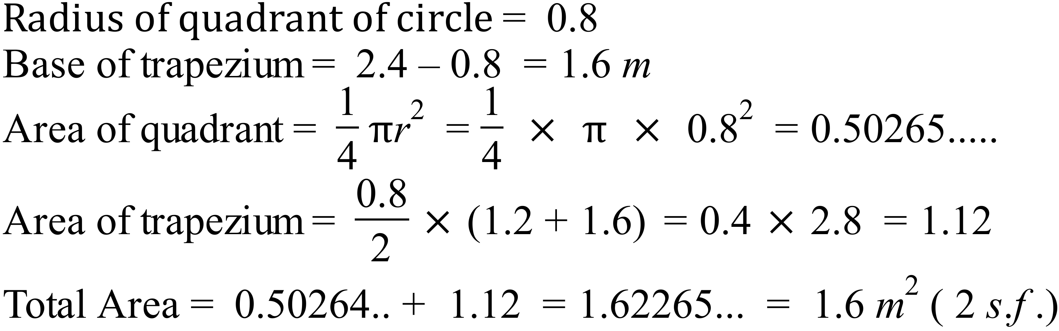 | C
 | 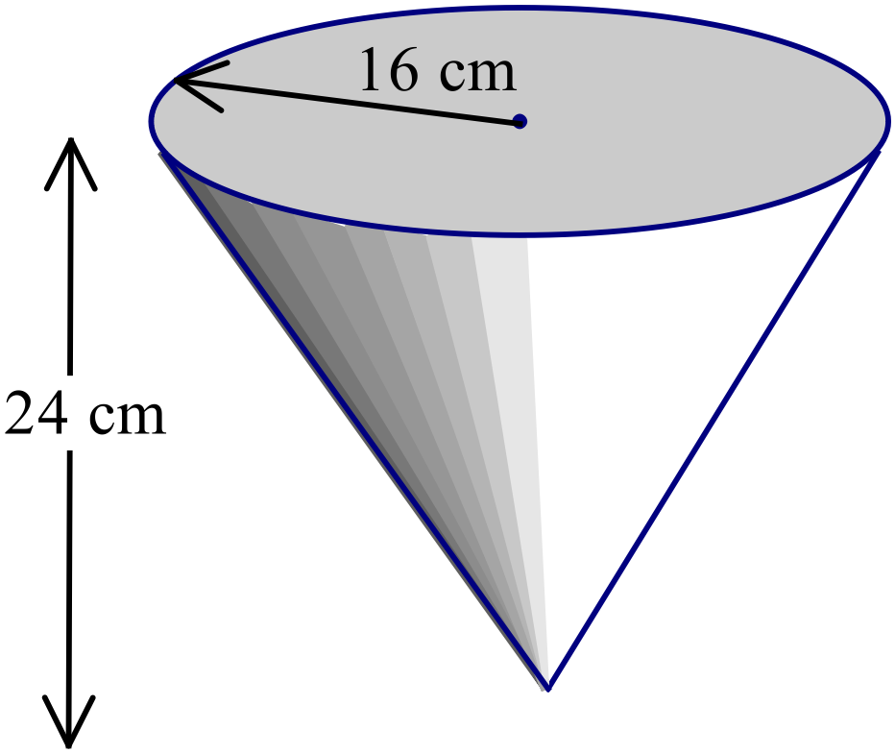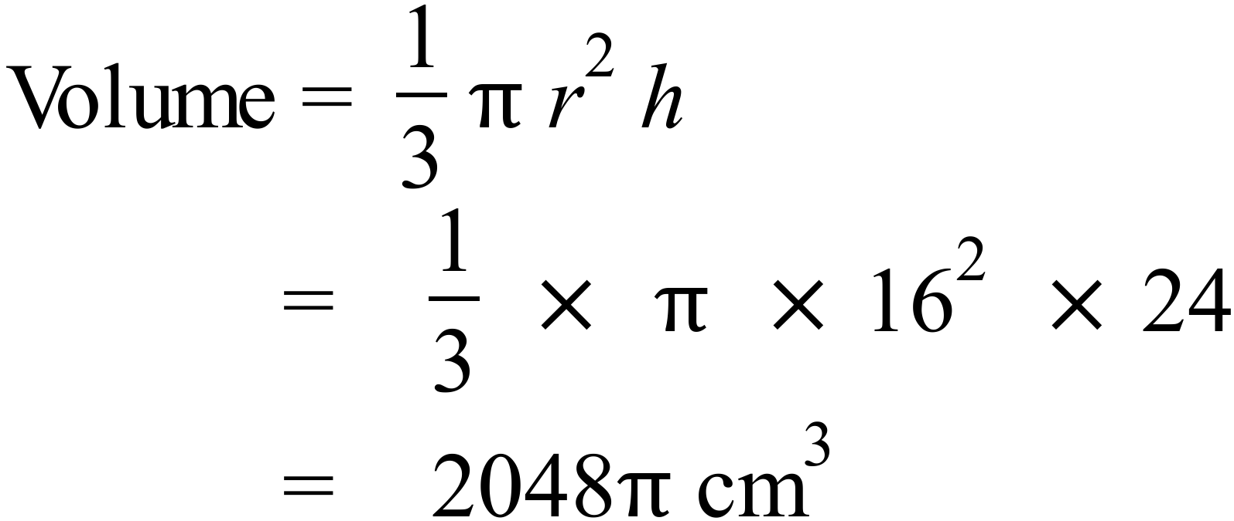 | D
 | 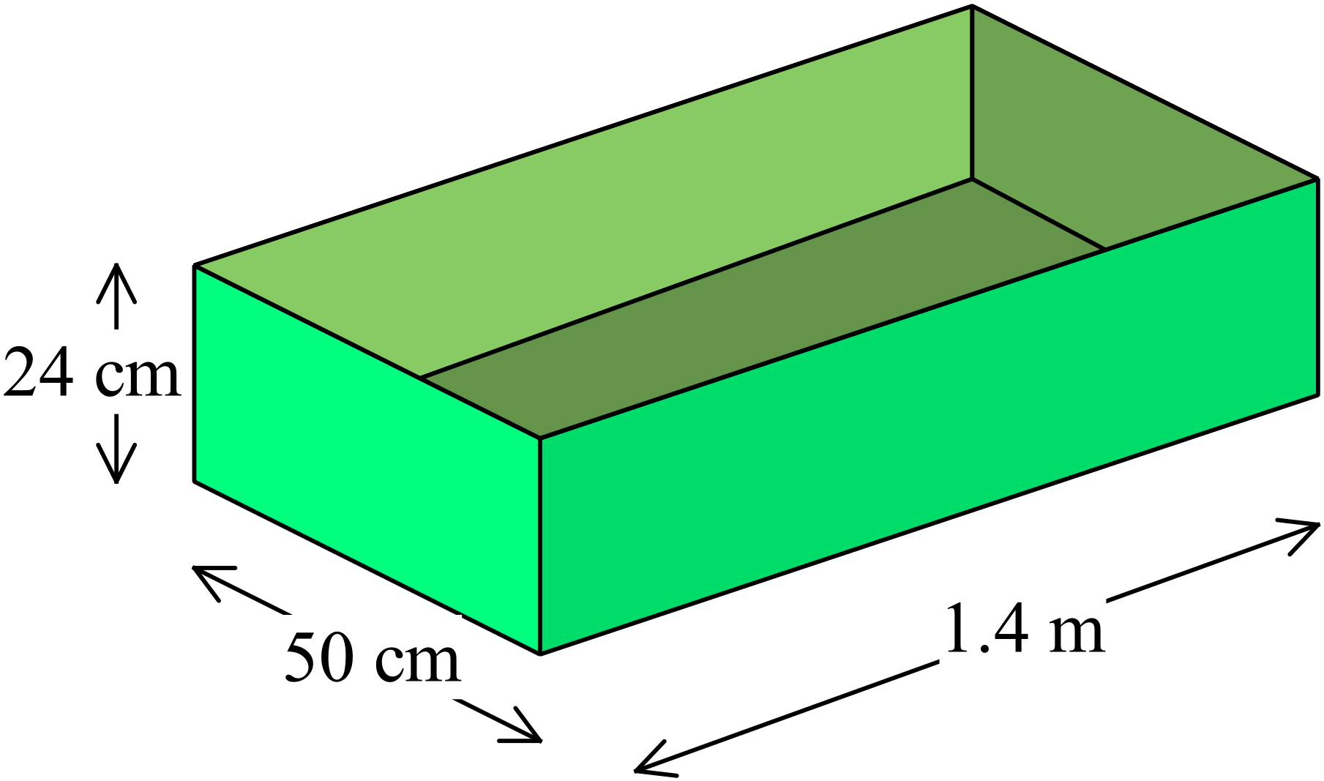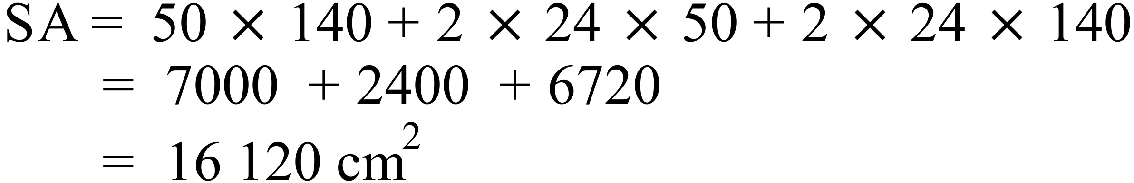 | C
 | 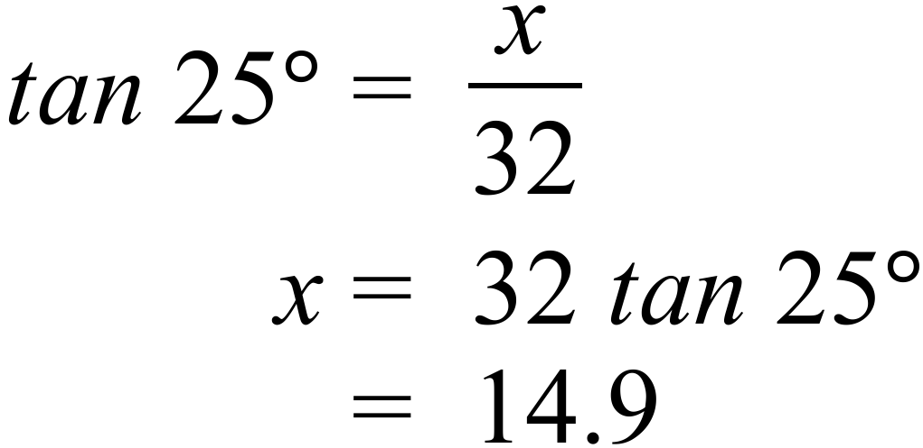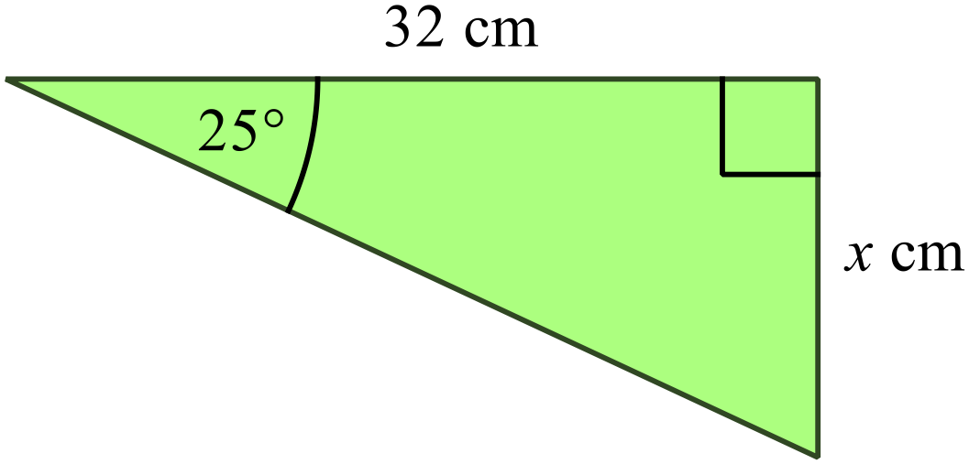 | B
 | 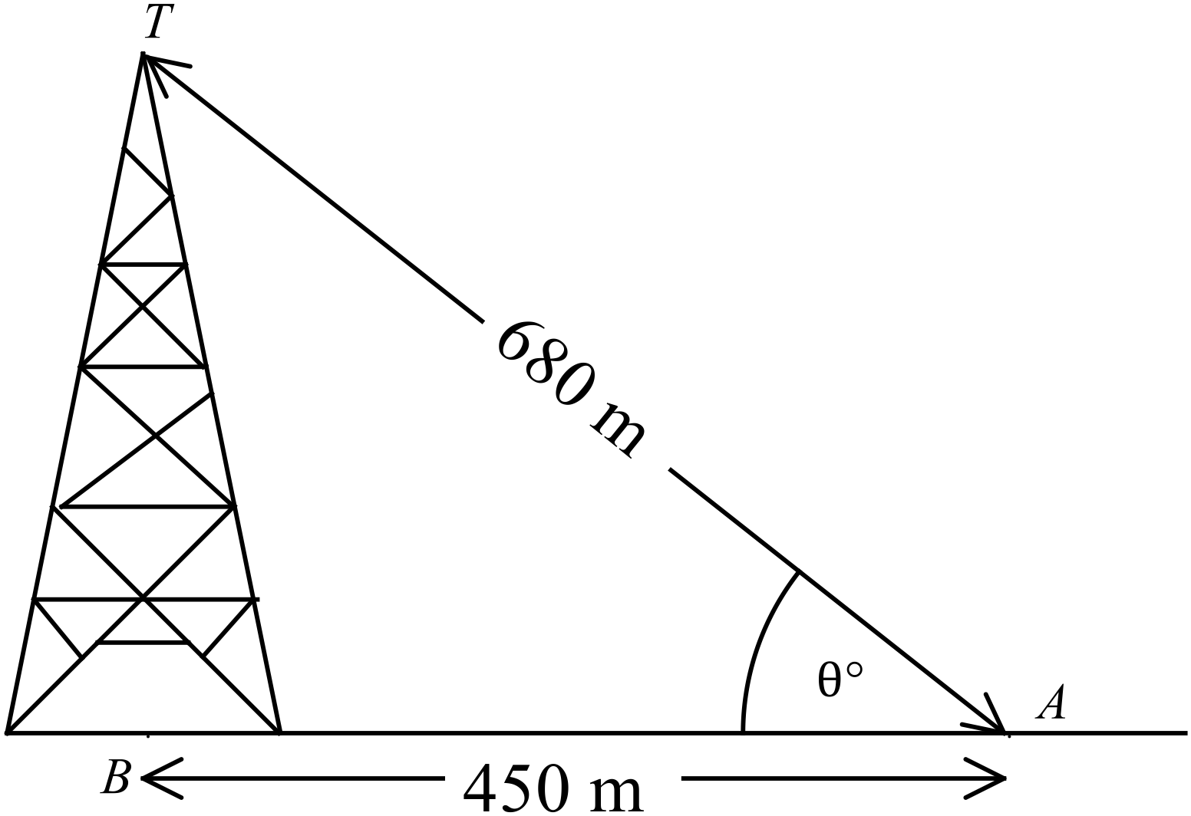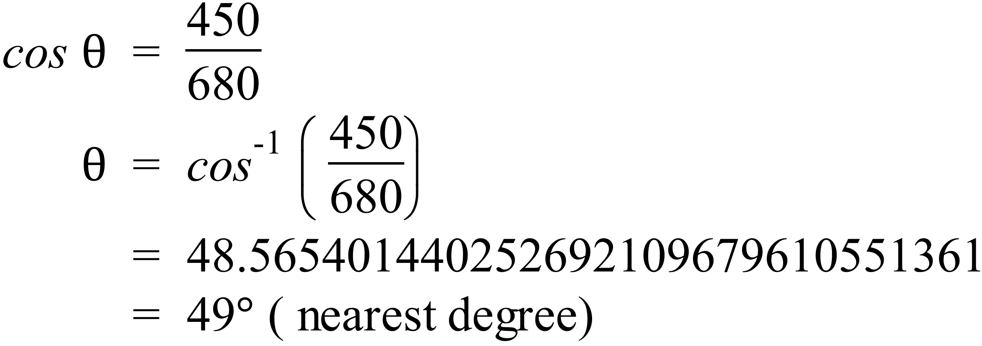 | C
 | 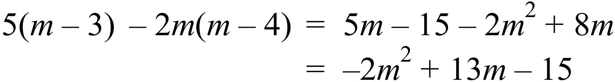 | B
 | 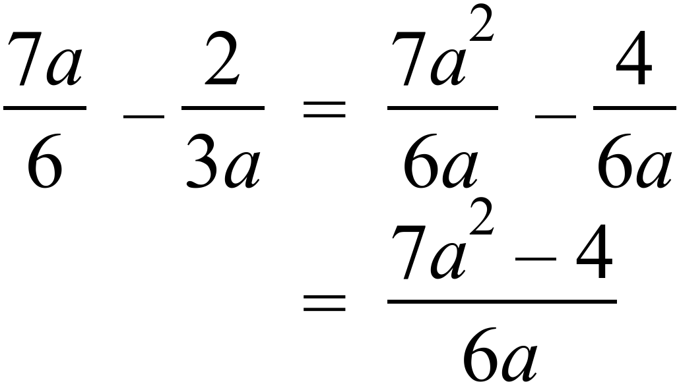 | D
 | 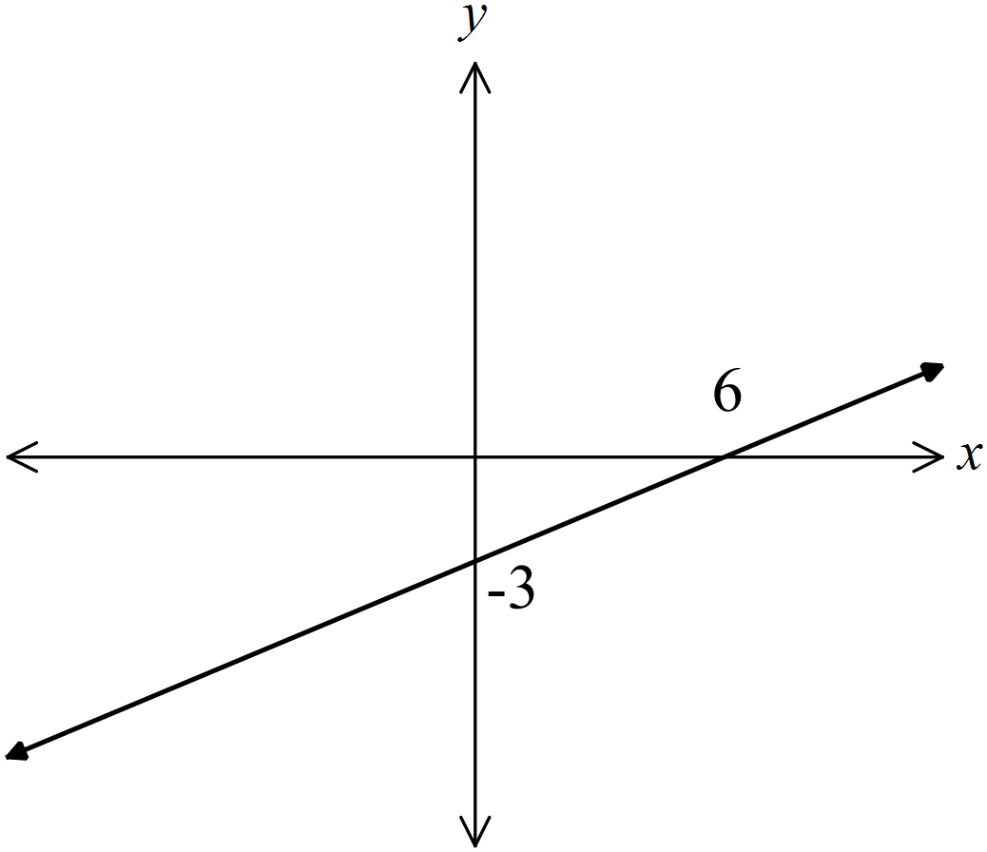 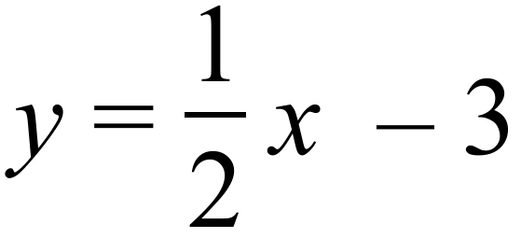 has a gradient of 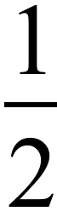 and a y intercept of -3.  A. | A
 | Noah’s average speed on his return journey 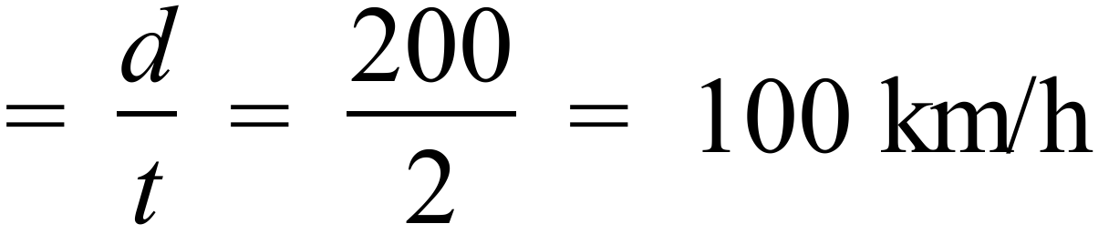  So statement A is not true. The others are all correct. | A
 | The others are all equal to 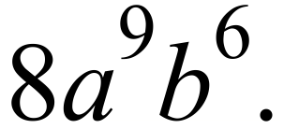 | B
 | A and B both include equality signs so do not match the graph 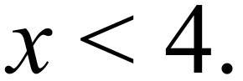  C has solution with inequality in opposite direction.  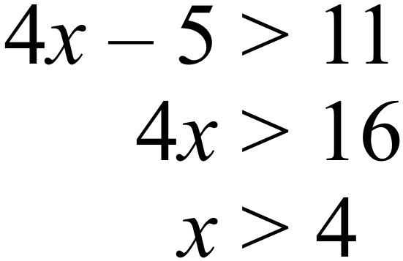  D has correct solution  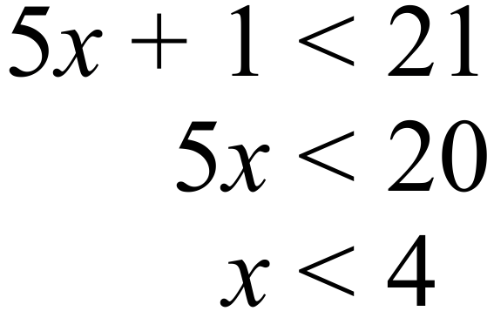 | D
 | 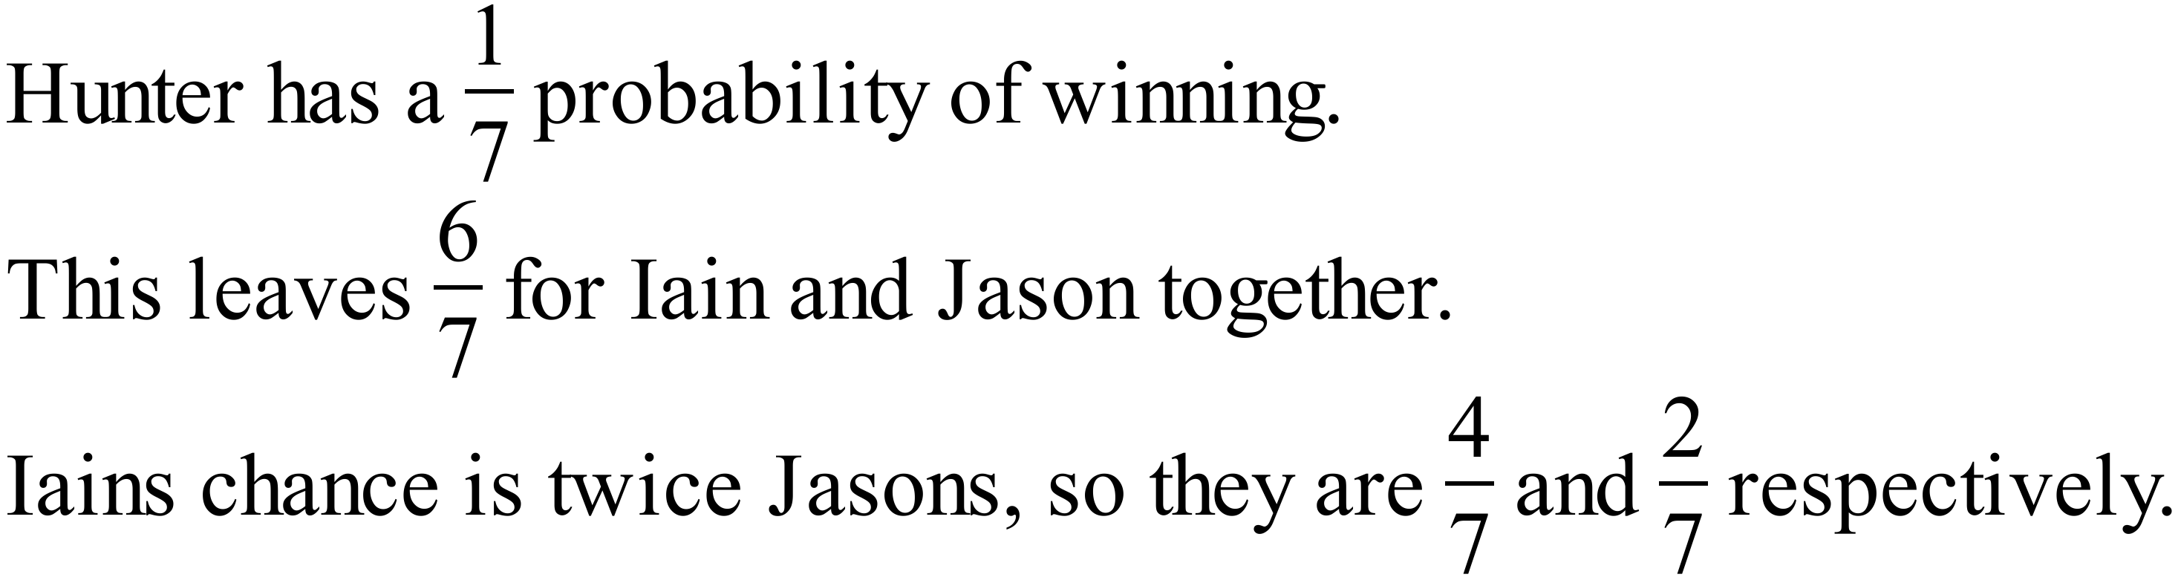 | A
 | 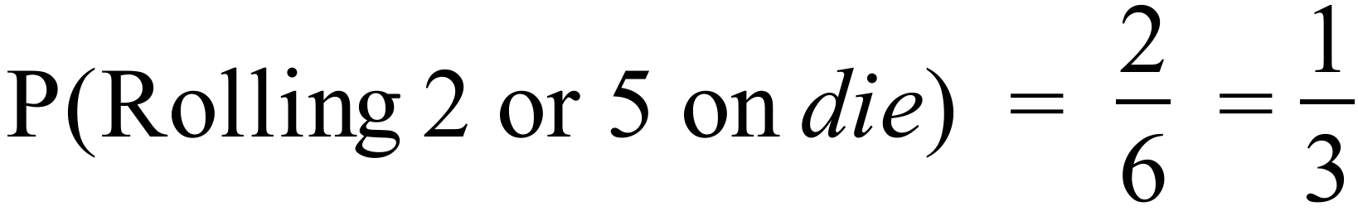  The others will not always have a probability of 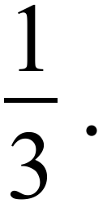 | A
 | - The median is calculated using all the prices and the mean is not.  Both are found using all the prices.  - The median gives a better indication of the spread of the data.  The median gives no indication of the spread.  - The median is less effected by outliers than the mode.  Neither are affected by outliers.  - The median is less effected by outliers than the mean.  The mean can be effected by a few very large (or small) prices. | D
 | 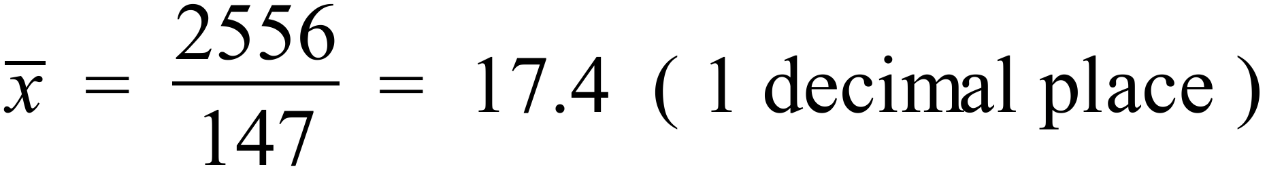  Or by entering data in scientific calculator. | B
  Class Centre | Frequency | fx
  3 | 6 | 18
  8 | 15 | 120
  13 | 35 | 455
  18 | 40 | 720
  23 | 37 | 851
  28 | 14 | 392
   | 147 | 2556
 | Both B and C indicate linear relationships, and C has a positive gradient. | C

2014 Yearly Mathematics Exam
Longer Answer Section
Answers
76. | - Total Sales = $12 500 + $24 000 + $45 000 = $81 500 | 2 marks for correct answer.  1 mark if one of the values is correctly calculated or a simple error is made.
 |  | 1 mark for correct answer.
77. | 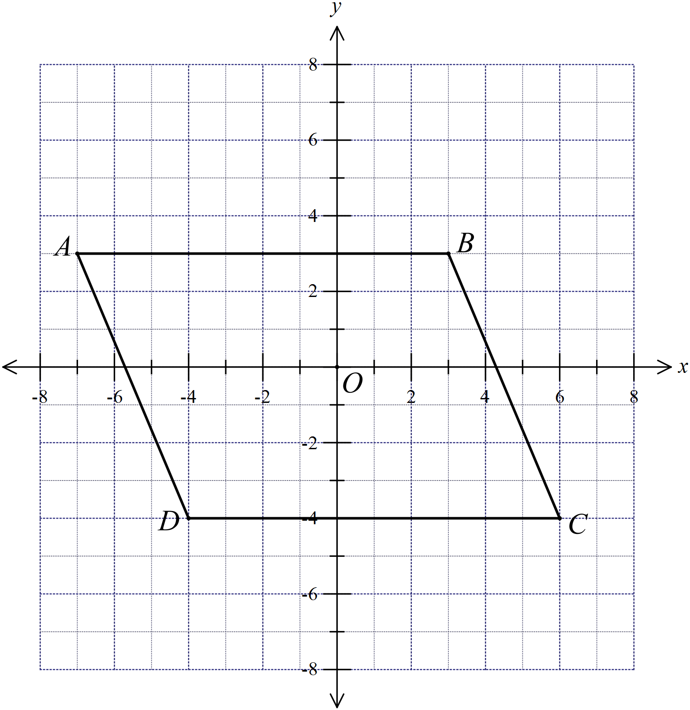
 | - Both lines are parallel to the x axis, hence they are parallel.  Both lines are horizontal, hence they are parallel. | 1 mark for any reasonable explanation.
 | - 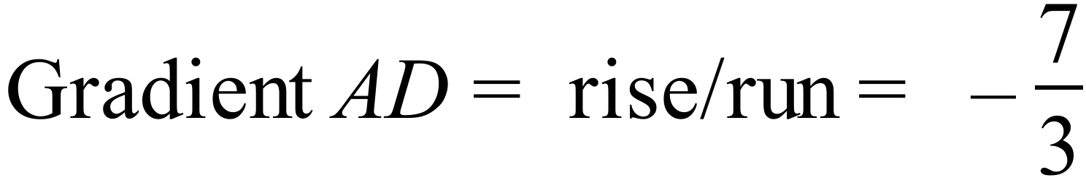  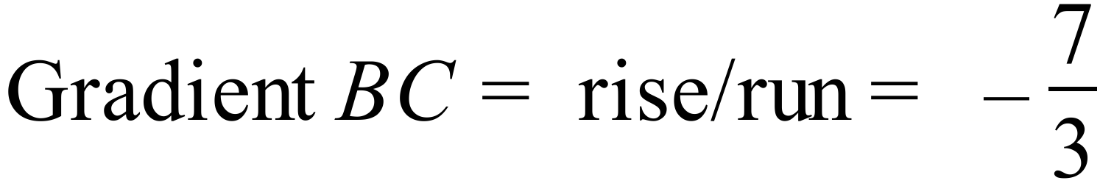  So the two intervals are parallel. | 1 mark for any reasonable explanation that includes the gradient of AD.
 | - The quadrilateral is a parallelogram, since there are two pairs of opposite sides parallel. | 1 mark for correct name.
 | - Area = | 1 mark for correct area.
78. | 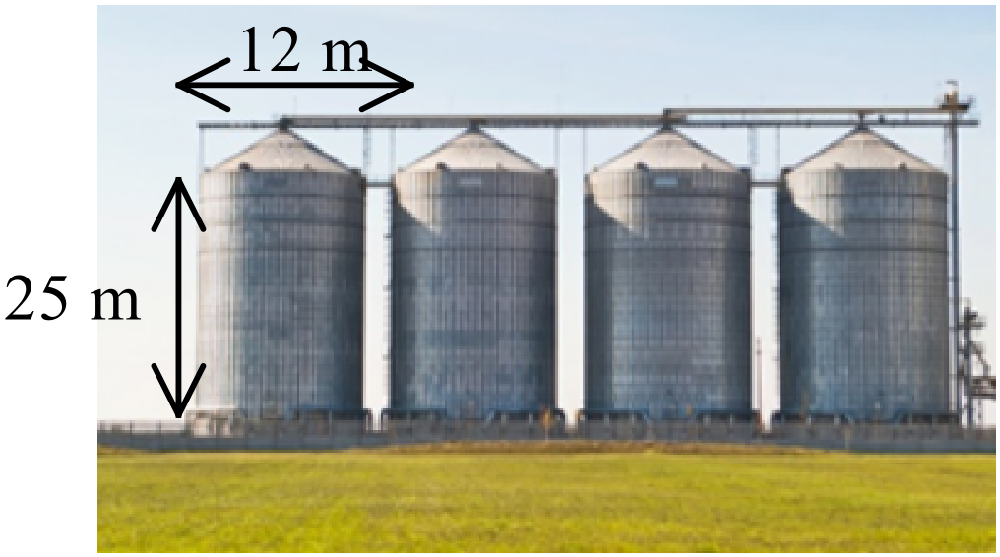(a)  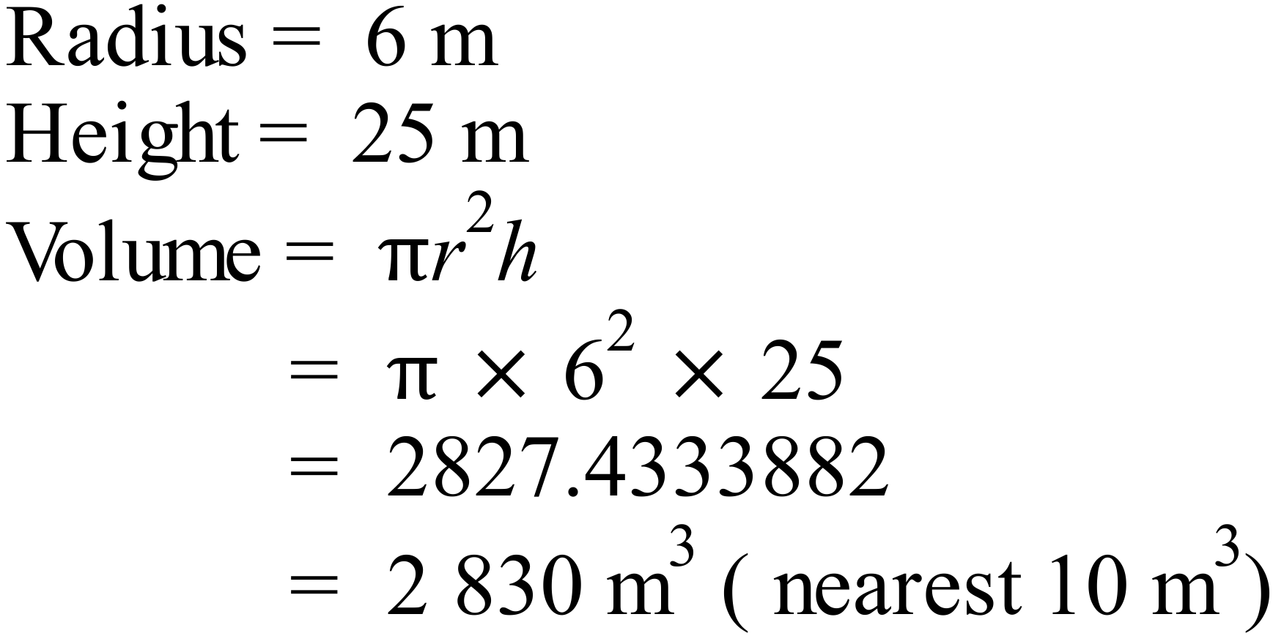 | - mark for correct answer.
 | (b) 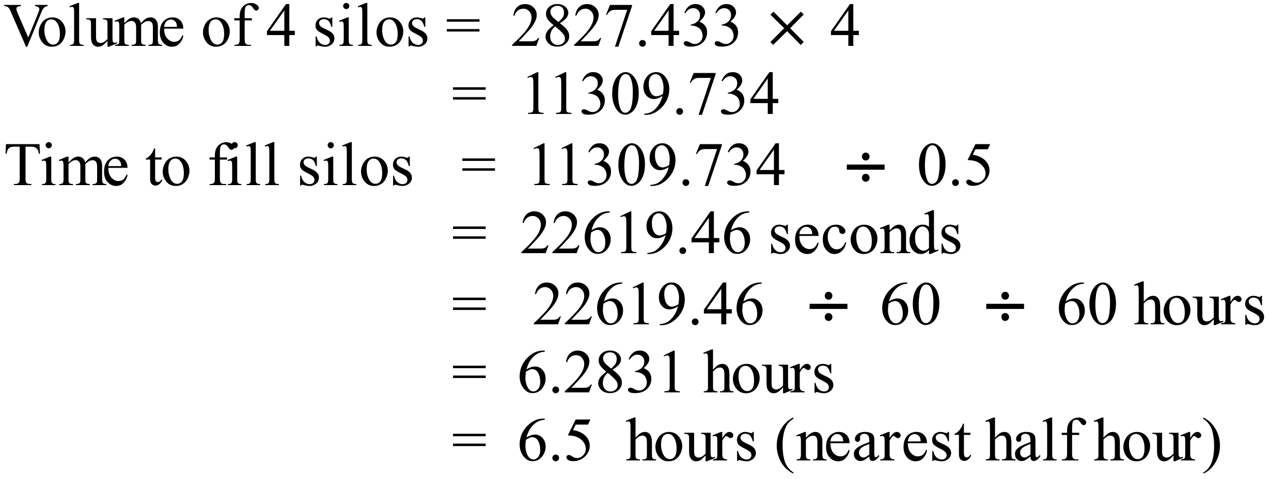 | 1 mark for correct answer.
79. | 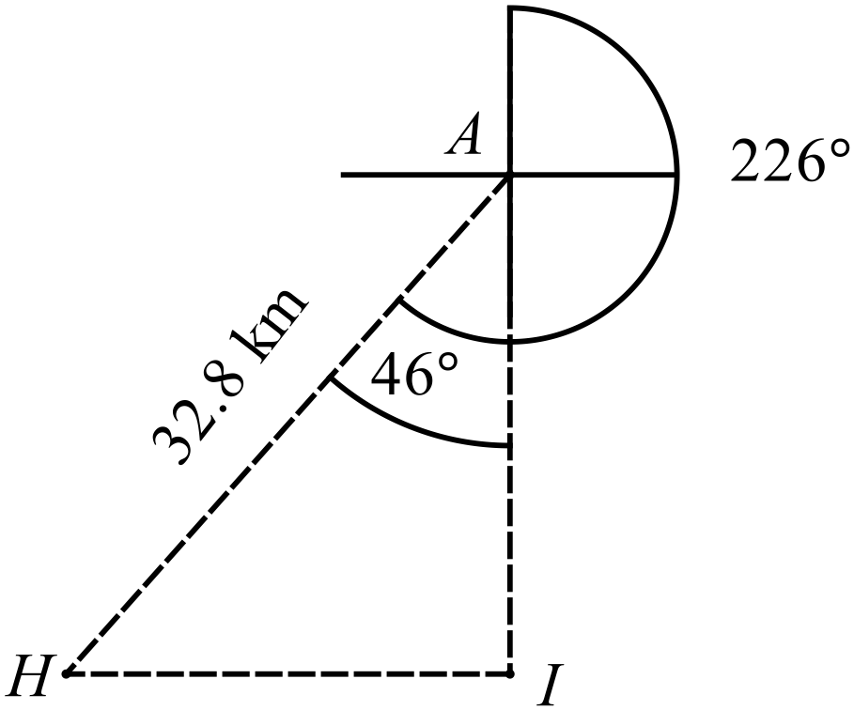(a) | 1 mark if the distance is shown correctly and either of the angles shown is provided correctly.
 | (b)  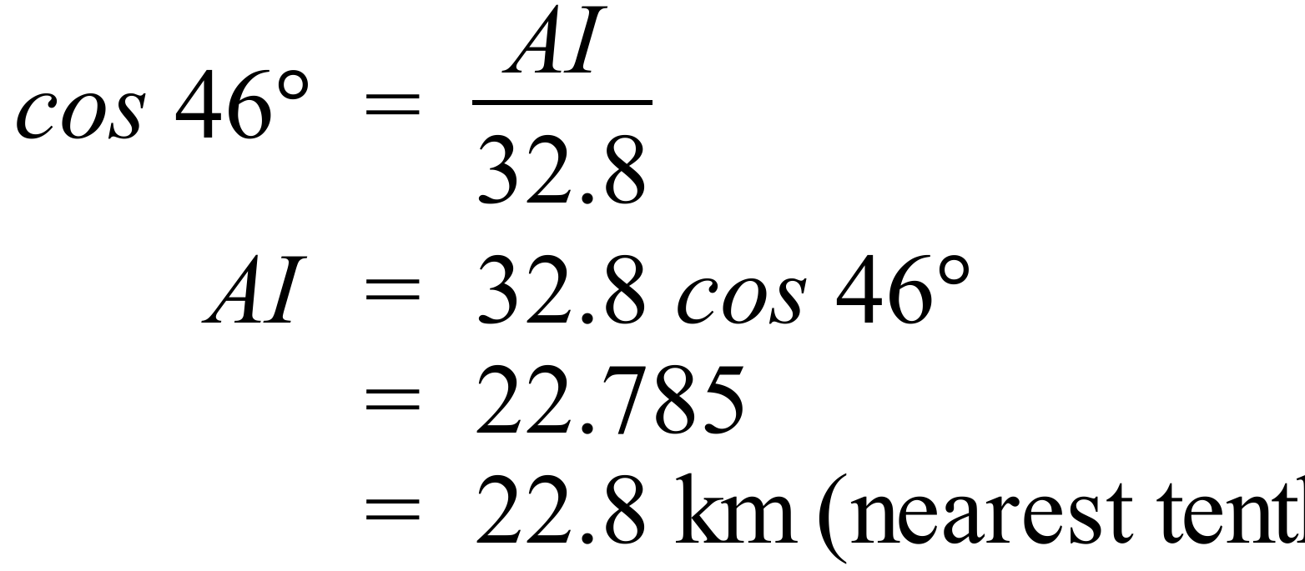 | 1 mark for correct answer.
 | (c)  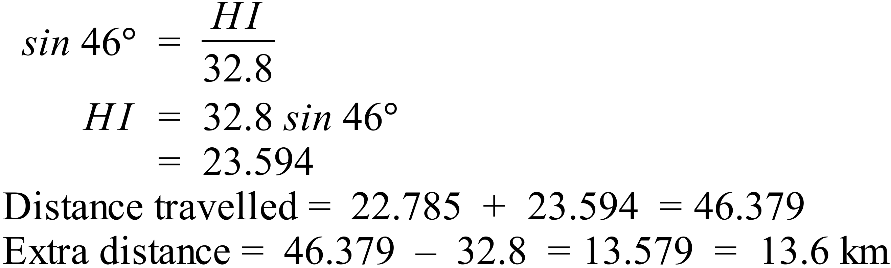 | 2 marks for correct answer to HI and extra distance,  1 mark for calculating either HI or extra distance correctly.
80.
   | 1 | 2 | 3 | 4 | 5 | 6
  1 | 1, 1 | 1, 2 | 1, 3 | 1, 4 | 1, 5 | 1, 6
  2 | 2, 1 | 2, 2 | 2, 3 | 2, 4 | 2, 5 | 2, 6
  3 | 3, 1 | 3, 2 | 3, 3 | 3, 4 | 3, 5 | 3, 6 | Same Number
  4 | 4, 1 | 4, 2 | 4, 3 | 4, 4 | 4, 5 | 4, 6
  5 | 5, 1 | 5, 2 | 5, 3 | 5, 4 | 5, 5 | 5, 6 | Product 12
  6 | 6, 1 | 6, 2 | 6, 3 | 6, 4 | 6, 5 | 6, 6
 | (a) 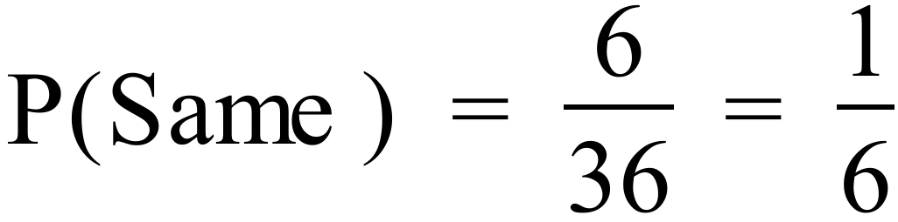 | 1 mark for correct answer - doesn’t need to be simplified.
 | (b) 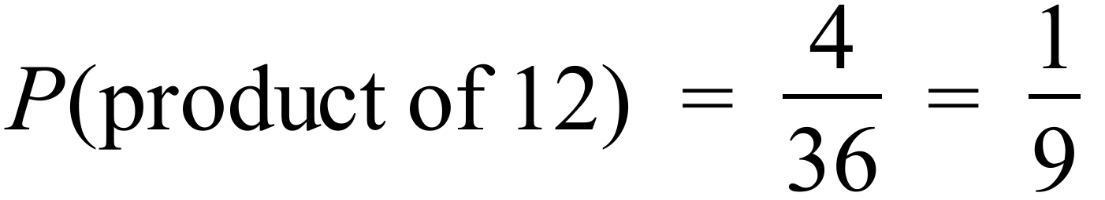 | 1 mark for correct answer - doesn’t need to be simplified.
81.
   |  |  | ● |  | ●
   |  |  | ● |  | ● |  | ●
   |  | ● | ● |  | ● | ● | ●
   | ● | ● | ● |  | ● | ● | ● | ●
   | ● | ● | ● | ● | ● | ● | ● | ●
   | 3 | 4 | 5 | 6 | 7 | 8 | 9 | 10
 | (a) Bimodal means that there are two modes, in this case 5 and 7 both occur the same number of times and more than any other scores. | 1 mark for correct explanation
 | (b) There are 25 scores, so the median is the 13th score, with 12 below and 12 above.  Counting though the 13th score is 7. | 1 mark for correct answer
 | - Sum of scores  =  = 164  Mean = 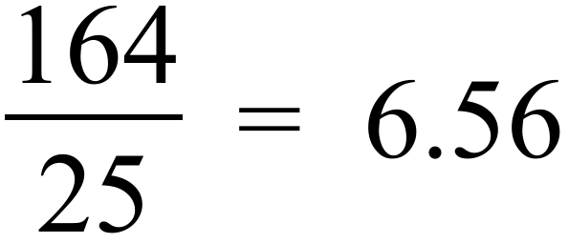 | 1 mark for correct answer
82. | 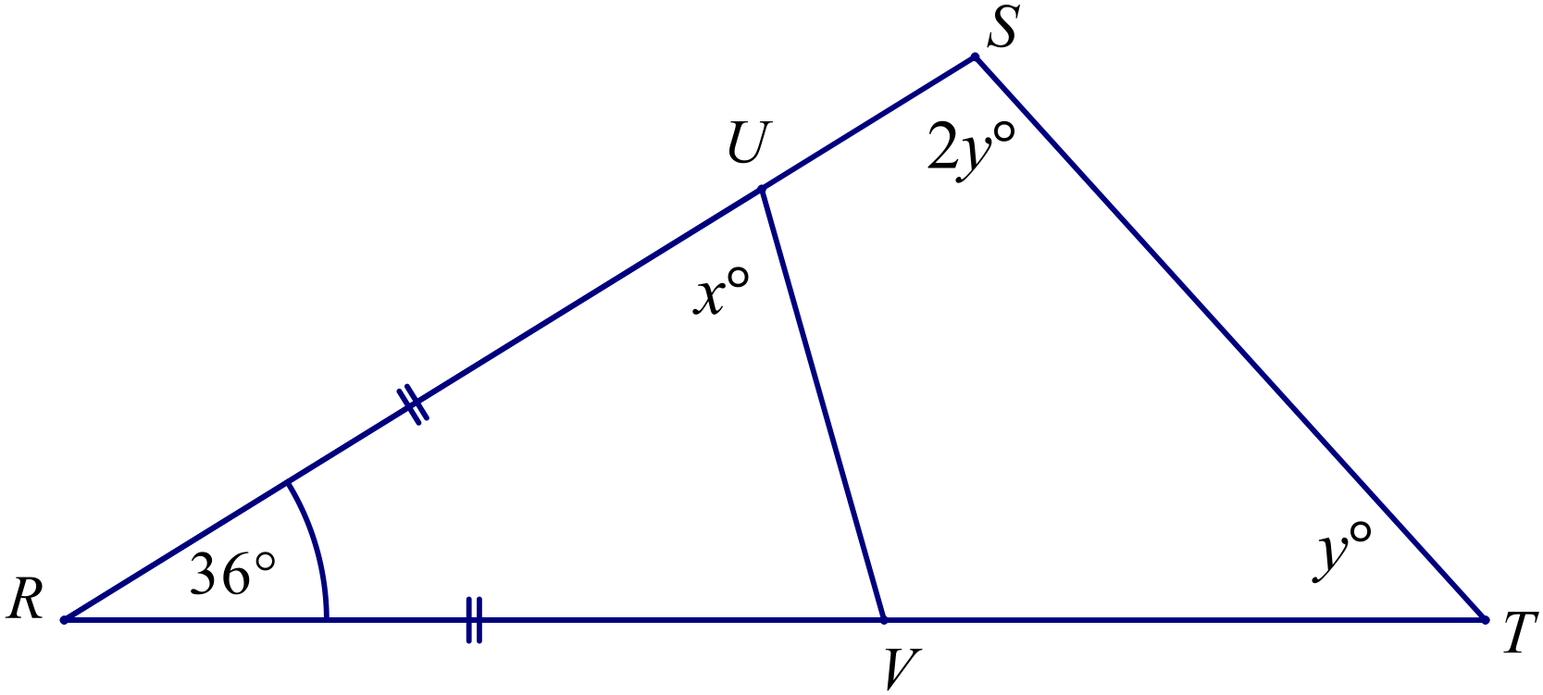
 | (a)  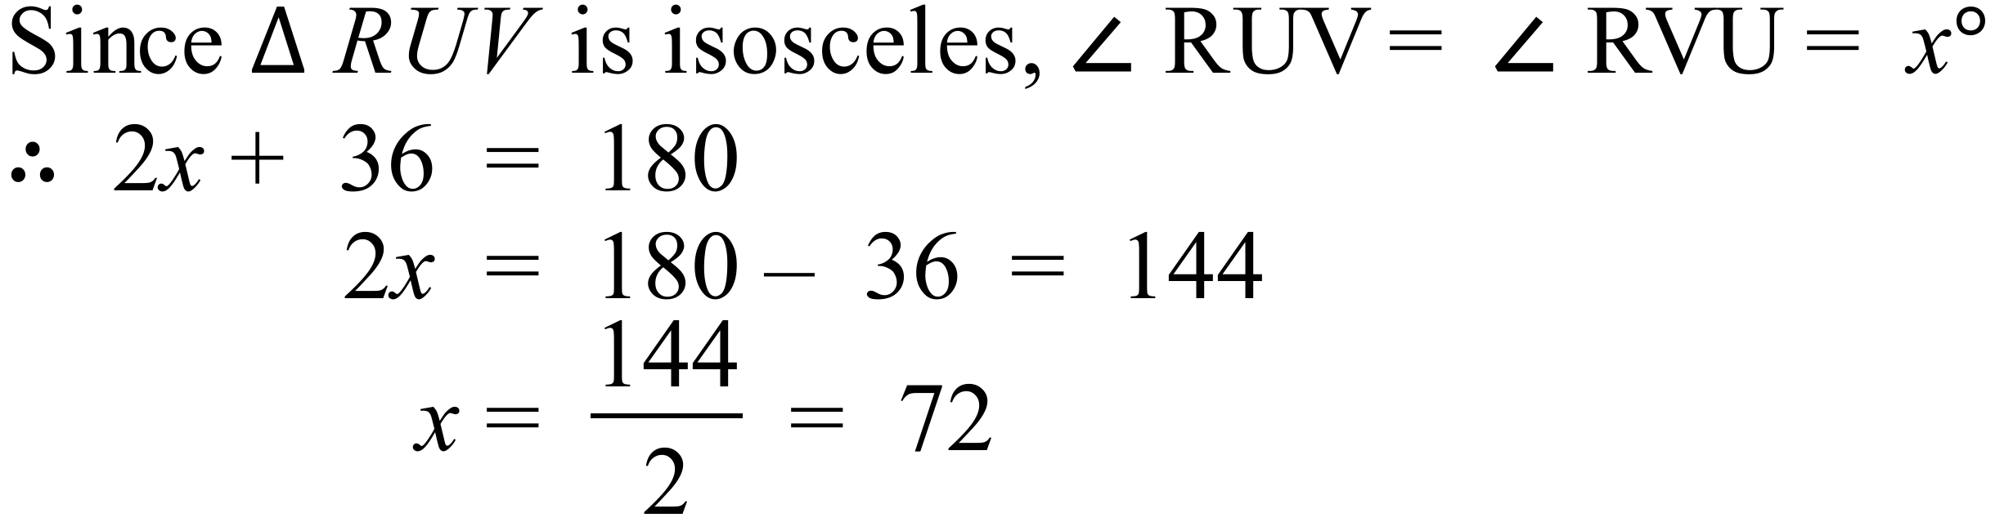 | 1 mark for correct reasoning.
 | (b) 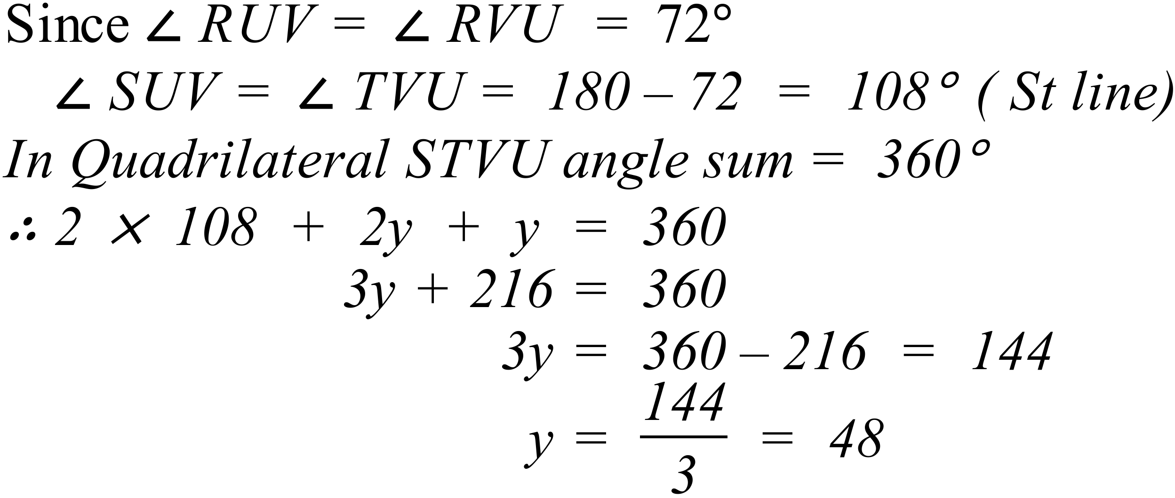 | 2 marks for correct answer with correct reasoning.  1 mark if an arithmetic/algebraic error is made, with correct reasoning, or a minor error in reasoning is made.
83. | 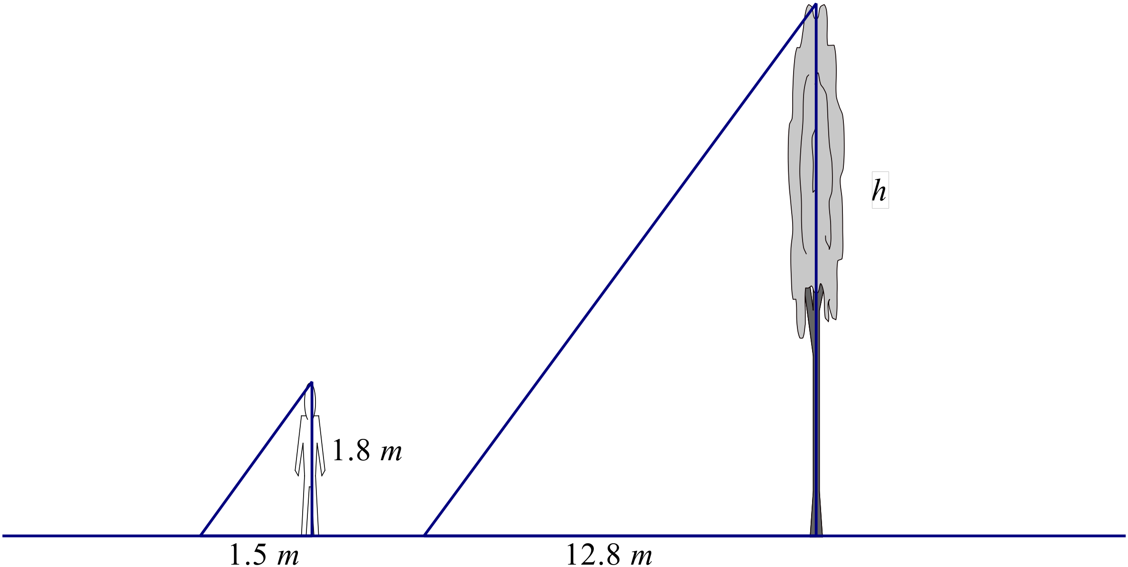  Since the angle of the sun is the same for both the tree and the man and they are both vertical, the triangles are equiangular, so they are also similar.  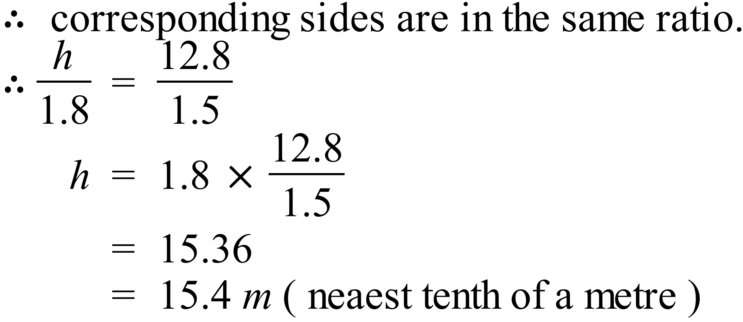 | 2 marks for correct answer with correct reasoning.  1 mark if an arithmetic/algebraic error is made, with correct reasoning, or a minor error in reasoning (eg incorrect matching of sides) is made with correct calculations.

High School
2014 Yearly Exam
Mathematics Course
Multiple Choice Section Answer Sheet
Name ________________________________ Teacher ________________________

Completely fill the response oval representing the most correct answer.

26. A B C D
27. A B C D
28. A B C D
29. A B C D
30. A B C D
31. A B C D
32. A B C D
33. A B C D
34. A B C D
35. A B C D
36. A B C D
37. A B C D
38. A B C D
39. A B C D
40. A B C D
41. A B C D
42. A B C D
43. A B C D
44. A B C D
45. A B C D
46. A B C D
47. A B C D
48. A B C D
49. A B C D
50. A B C D

51. A B C D
52. A B C D
53. A B C D
54. A B C D
55. A B C D
56. A B C D
57. A B C D
58. A B C D
59. A B C D
60. A B C D
61. A B C D
62. A B C D
63. A B C D
64. A B C D
65. A B C D
66. A B C D
67. A B C D
68. A B C D
69. A B C D
70. A B C D
71. A B C D
72. A B C D
73. A B C D
74. A B C D
75. A B C D

